**Klarna Payments**

Version 17.4.0



Table of Contents

1. Summary 1-4

2. Component Overview 2-5

2.1 Functional Overview 2-5

2.2 Use Cases 2-5

2.3 Limitations, Constraints 2-16

2.4 Compatibility 2-17

2.5 Privacy, Payment 2-17

3. Implementation Guide 3-21

3.1 Setup 3-21

3.1.1 int_klarna_payments 3-21

3.1.2 int_klarna_payments_pipelines 3-22

3.1.3 int_klarna_payments_controllers 3-22

3.2 Configuration 3-22

3.2.1 Metadata Import 3-22

3.2.2 Cartridge Path 3-33

3.2.3 Klarna Payments Configurations 3-34

3.2.4 Klarna Payments Logo and Payment Option Name 3-35

3.2.5 Services Configuration 3-36

3.2.6 Custom attributes 3-37

3.3 Custom Code 3-37

3.3.1 Integration efforts 3-37

3.3.2 Templates modifications 3-38

3.3.3 Pipeline modifications 3-41

3.3.3.1 COBilling pipeline 3-41

3.3.3.2 COSummary pipeline. 3-42

3.3.3.3 COPlaceOrder pipeline. 3-43

3.3.4 Controller modifications 3-44

3.3.4.1 COBilling controller. 3-44

3.3.4.2 COSummary controller. 3-45

3.3.4.3 OrderModel.js 3-46

3.4 External Interfaces 3-46

3.5 Testing 3-47

4. Operations, Maintenance 4-48

4.1 Data Storage 4-48

4.2 Availability 4-48

4.3 Support 4-48

5. User Guide 5-49

5.1 Roles, Responsibilities 5-49

5.2 Business Manager 5-49

5.3 Storefront Functionality 5-49

6. Known Issues 6-50

7. Release History 7-51

# Summary

This cartridge enables a Commerce Cloud store to use the Klarna Payments service.

The developer has to install the cartridge and integrate it into online store following the instructions from this document. It is mandatory that the merchant has to open an account with Klarna and configure some items in Commerce Cloud Business Manager to make the integration working properly.

Klarna offers a test environment, so the integration can be tested before switching to the Klarna production environment.

The integration consists of an archive, which contains the following contents:

* Cartridge called ‘int_klarna_payments’, and optionally either "int_klarna_payments_pipelines" or "int_klarna_payments_controllers" depending on which architecture is to be employed.
* A site-template archive containing new attributes and settings
* This document
* The integration is based on the Site Genesis demo store provided by Commerce Cloud.

# Component Overview

## Functional Overview

Short description of the Klarna Payments system

Klarna Payments can receive payments in via the Klarna Payments API using JSON REST API and a JavaScript SDK. A result is returned right away. Through Klarna Payments you enable your consumers to try before they buy, finance purchases on your store via Klarna Credit, or make use of other payment methods made available by Klarna. Klarna offers these payment options via a widget, called Klarna Payments widget or just "the widget", which you add inline on your checkout page.

Klarna Payments uses the ‘redirect model’, where the customer is sent to the redirect_url as a last step of the process before showing the confirmation page. The reason for this redirect is to allow Klarna to recognize the customer's device in future interactions. Klarna needs to interact with the customer's browser as first party (not in an iframe or similar). This is achieved by ‘bouncing’ the browser on a klarna.com page before presenting the confirmation page.

Payment results are sent asynchronously to a 'notification URL' at the Merchant (SCC) site. Payments can change status over the time (Accepted, Rejected and Pending) on Klarna Payments side, and these statuses are updated automatically on the Commerce Cloud side through sending these notifications.

In case order is ACCEPTED order creation in SCC proceeds as usual, in case of REJECTED status, order is failed and in case of PENDING status the 'two phase ordering' approach is used, where the order is first created but only 'placed' after notification for ACCEPTED status is asynchronously received. If neither ACCEPTED, nor REJECTED status is received the order will stay in status ‘created’ until an action is taken by the merchant.

## Use Cases

1. Create an order in SCC using Klarna Payments as a payment method though Klarna Payments widget on the billing page. All the SCC OOTB checkout functionality remains in place, such as but not limited to: cart updates during checkout, checkout with applied coupon(s) code(s), checkout with applied product level promotion, checkout with applied order level promotion, checkout with applied shipping level promotion, checkout with applied order level promotion with bonus product.

Select 'Klarna' as the payment method on Billing page of checkout process and click the 'CONTINUE TO PLACE ORDER' button:

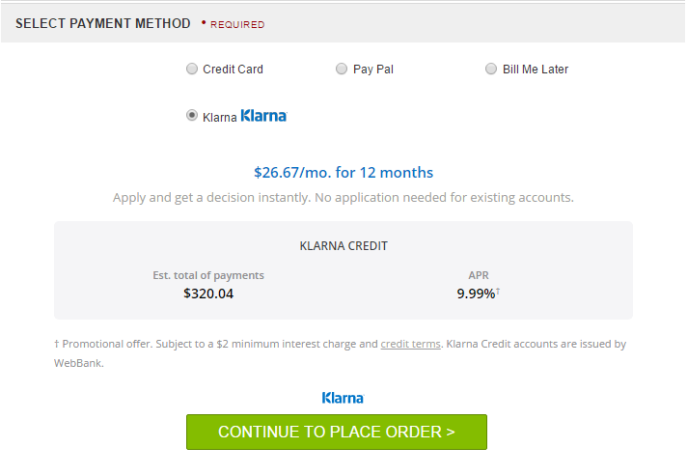

You will see the Order Confirmation page with payment method Klarna and can press the 'PLACE ORDER' button:

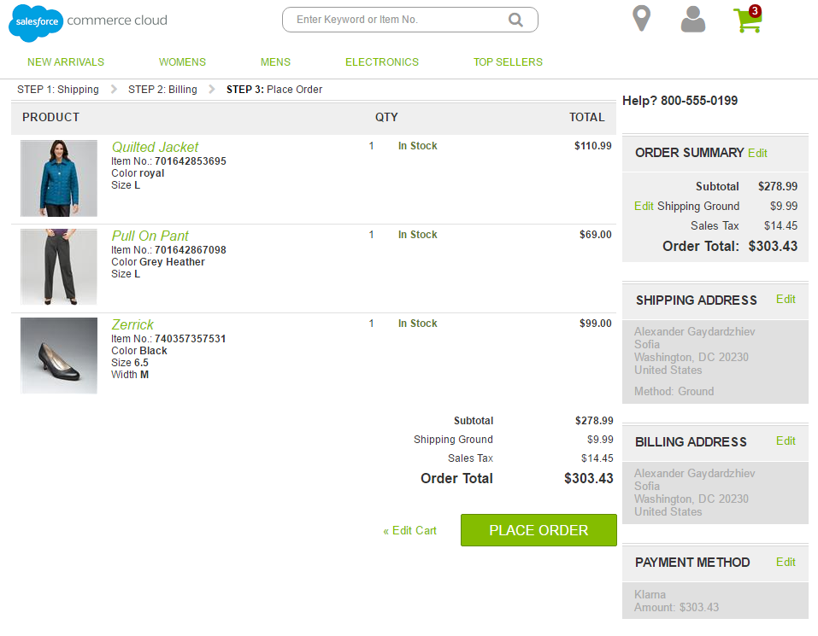

The customer is redirect to the redirect_url. The reason for this redirect is to allow Klarna to recognize the customer's device in future interactions. Klarna therefore needs to interact with the customer's browser as first party (not in an iframe or similar). This is achieved by ‘bouncing’ the browser on a klarna.com page before presenting the SCC Order Summary page:

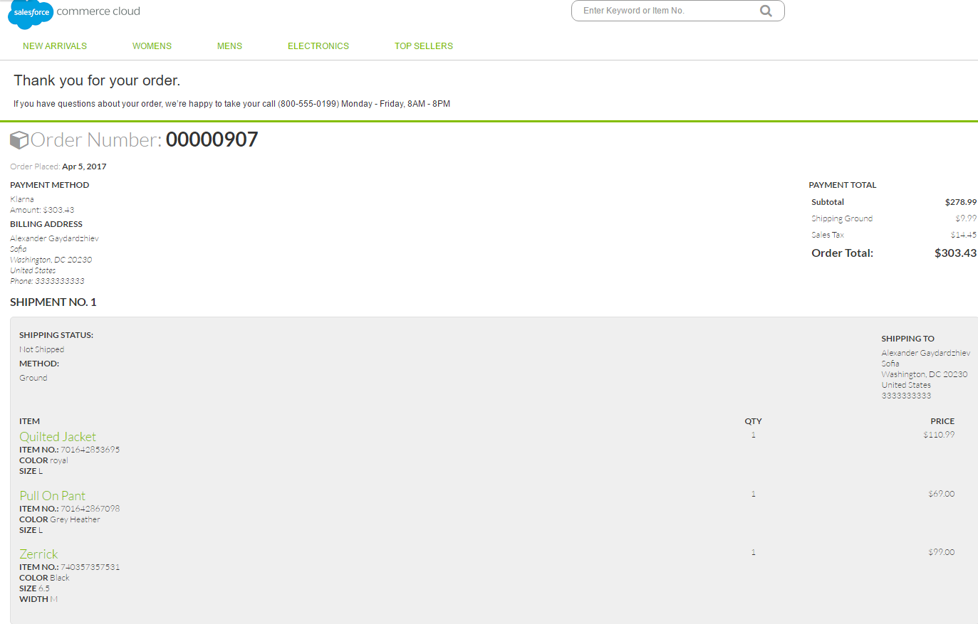

The newly created order can be the inspected in BM

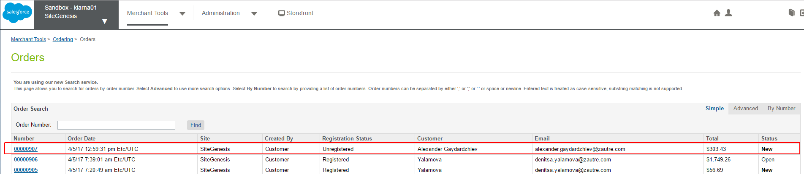

Klarna Payments order id can be inspected in the Attributes tab of the order

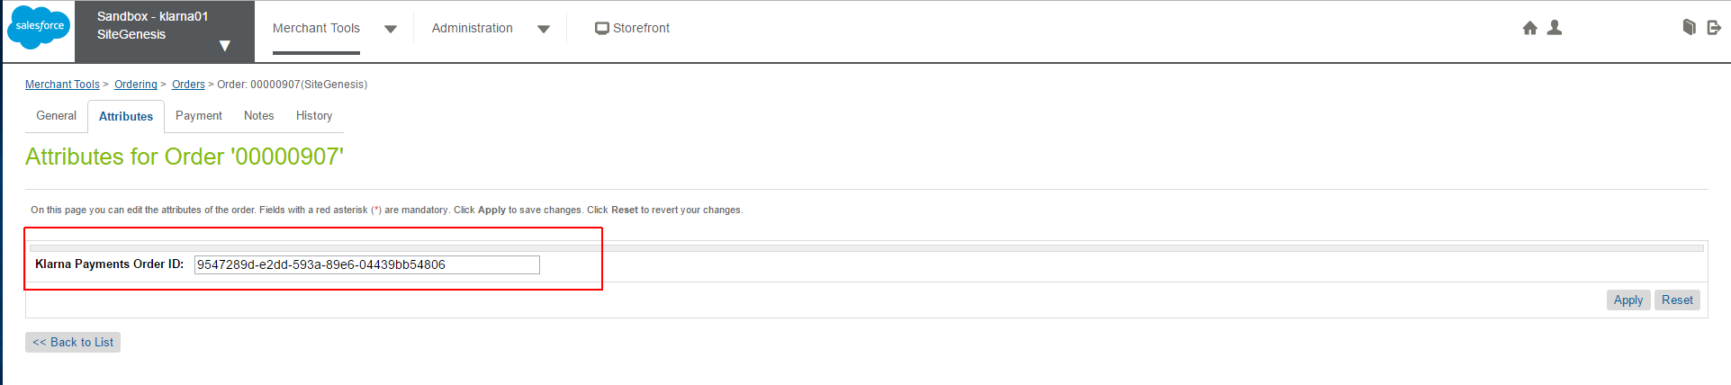

Payment method details can be inspected on the Payment tab of the order, and it should be Klarna

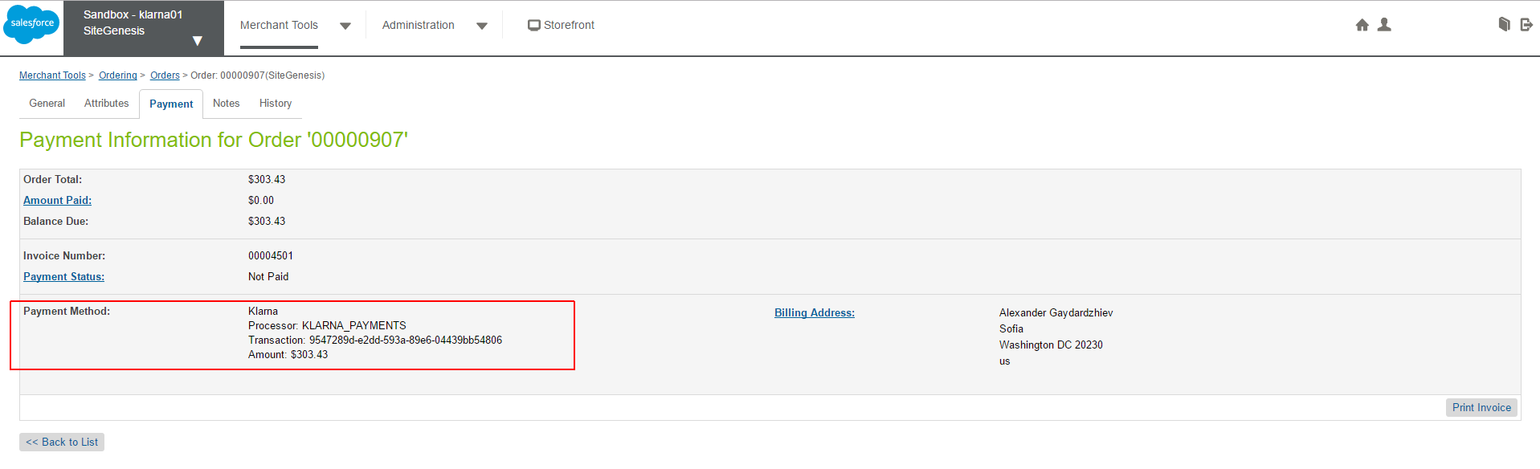

Order can be further inspected in Klarna Orders System

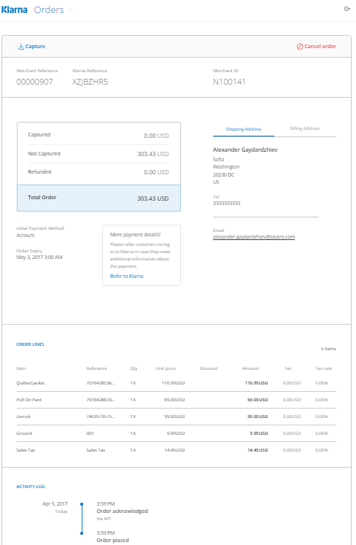

1. Refuse Klarna Payments as a payment method

Upon selecting 'Klarna' as the payment method on Billing page of checkout process and based on the information provided Kalrna Payments can be refused as a payment method.

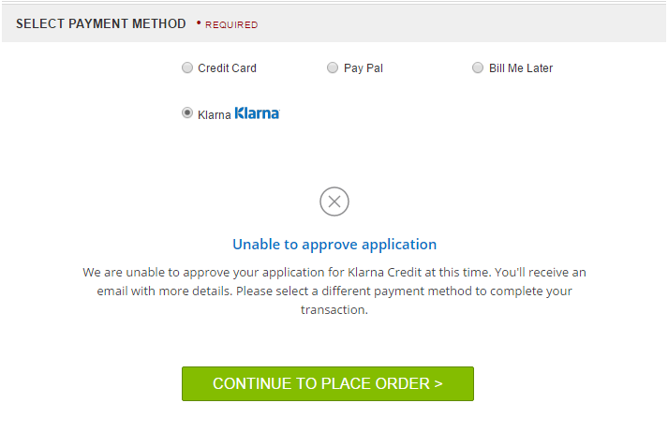

1. Klarna Payments not available – if Klarna API is not available, Klarna is not presented as a payment option

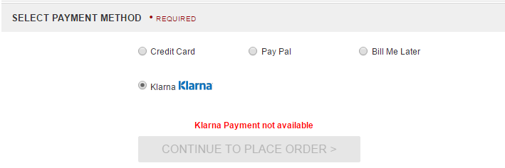

1. Order accepted after review - Instead of immediately accepting the order, it may happen that Klarna flags this transaction for additional review and accept it later on. The order is then created in the SCC system:

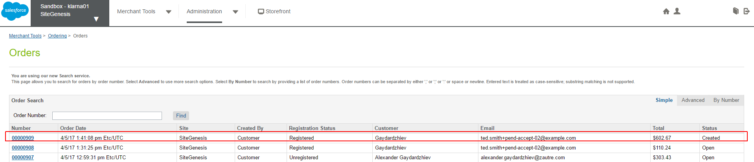

This order is marked with EXPORT_STATUS_NOTEXPORTED, confirmation status NOTCONFIRMED and NOTPAID.

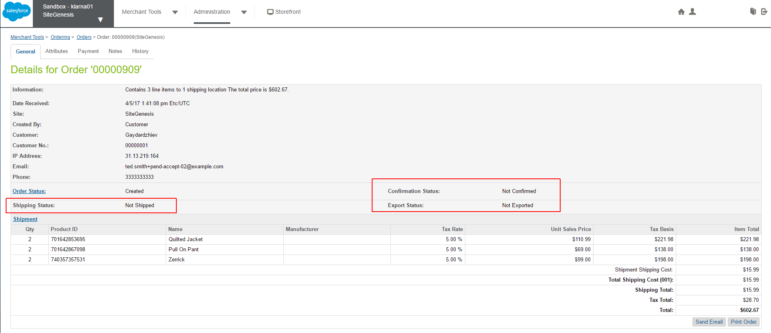

Upon receiving approval from Klarna the order is placed:

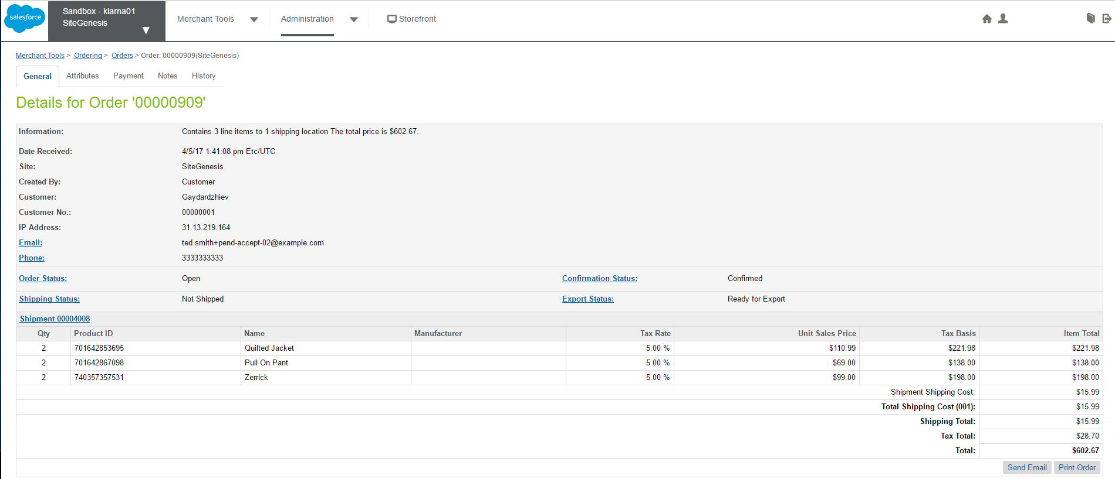

In Klarna Orders system the order is marked as accepted after review:

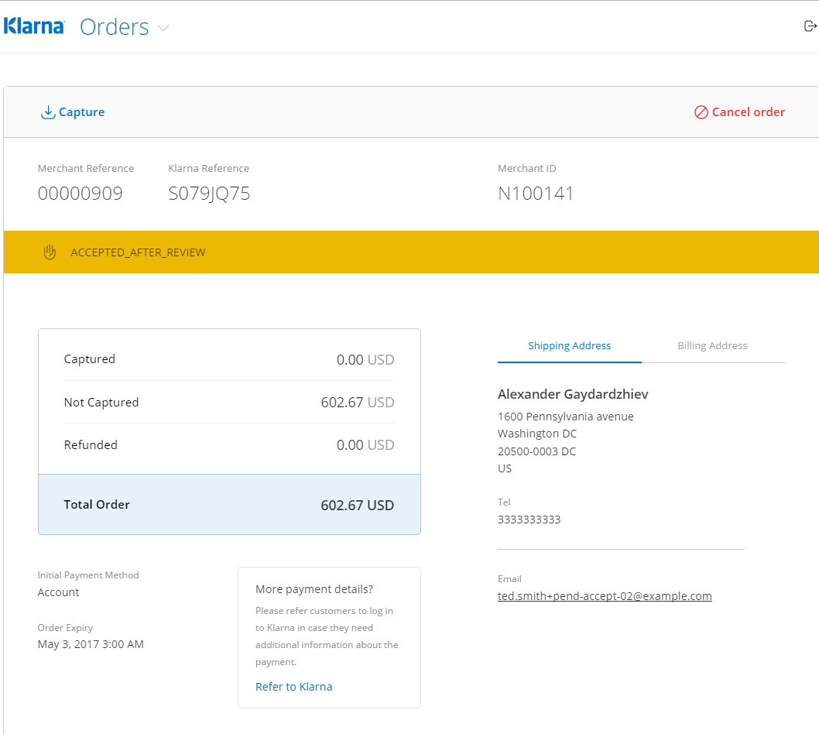

1. Order rejected after review - Instead of immediately accepting the order, it may happen that Klarna flags this transaction for additional review and reject it later on. The order is then created in the SCC system:

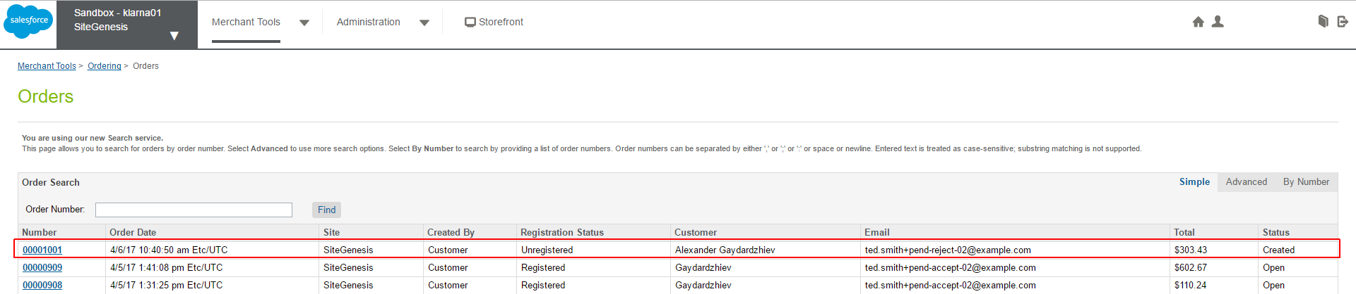

This order is marked with EXPORT_STATUS_NOTEXPORTED, confirmation status NOTCONFIRMED and NOTPAID.

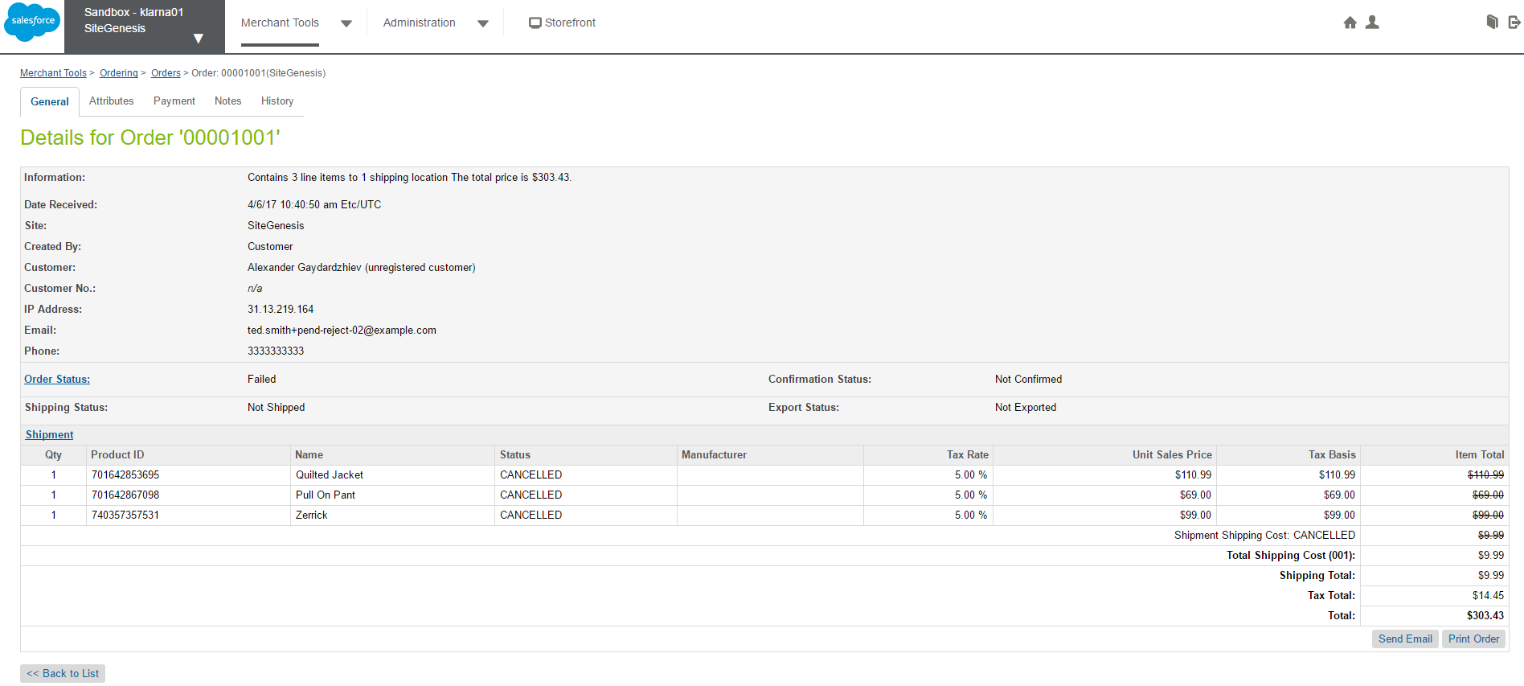

Upon receiving rejection from Klarna the order is failed:

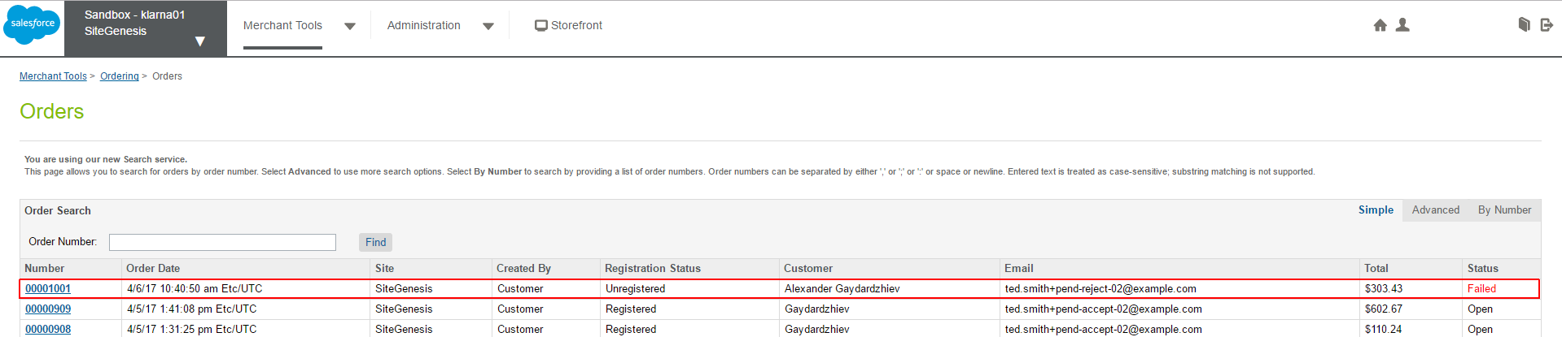

In Klarna Orders system the order is marked as rejected after review:

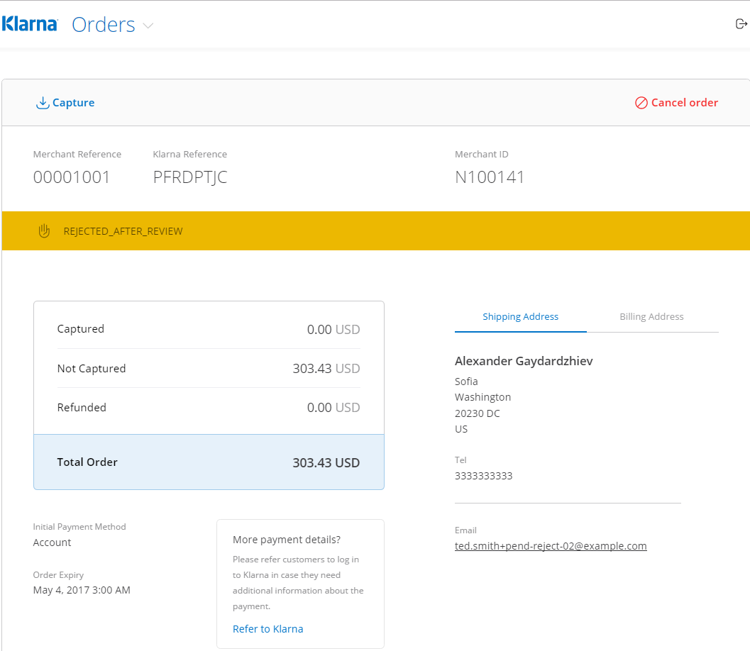

1. Klarna Payment optionnot available for the current purchase – the customer is presented with an appropriate message when attempt to chose Klarna is made.

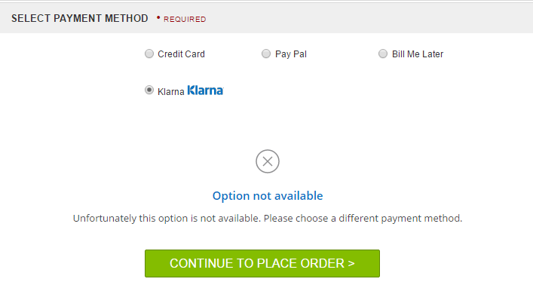

## Limitations, Constraints

The merchant will need a configured Klarna Payments account.

The merchant can style the Klarna Payments widget (skin), to make it matching the look and feel of their store. The list with the graphic elements that can be customized, through site preferences is as follows:

* "color_details" (site preference kpColorDetails): "#C0FFEE"
* "color_button" (site preference kpColorButton): "#C0FFEE"
* "color_button_text" (site preference kpColorButtonText): "#C0FFEE"
* "color_checkbox" (site preference kpColorCheckbox): "#C0FFEE"
* "color_checkbox_checkmark" (site preference kpCheckboxCheckmark): "#C0FFEE"
* "color_header"(site preference kpColorHeader): "#C0FFEE"
* "color_link"(site preference kpColorLink): "#C0FFEE"
* "color_border"(site preference kpColorBorder): "#C0FFEE"
* "color_border_selected"(site preference kpBorderSelected): "#C0FFEE"
* "color_text"(site preference kpColorText): "#C0FFEE"
* "color_text_secondary"(site preference kpColorTextSecondary): "#C0FFEE"
* "radius_border"(site preference kpRadiusBorder): "0px"

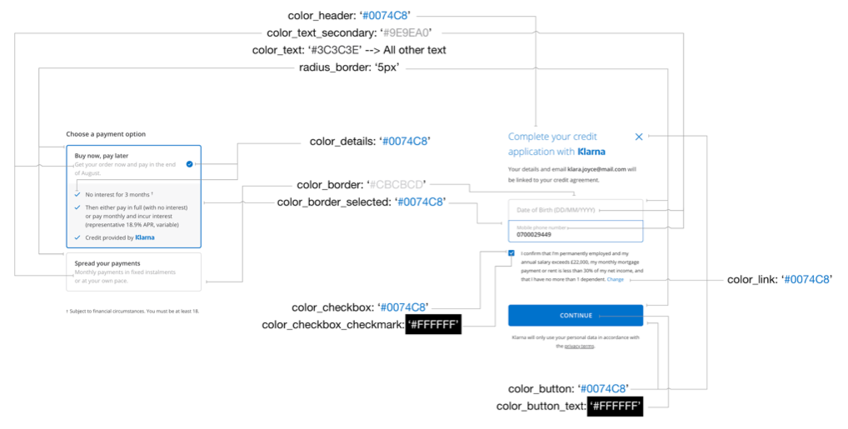

Successful payment authorizations (Klarna Payments status APPROVED) lead to a 'Paid' order payment status and ‘Ready for Export’ export status

Refused and pending payment authorizations (Klarna Payments statuses REJECTED and PENDING) lead to a 'Not Paid' order payment status, and ‘Not Exported’ export status

Cancels and refunds lead to a 'Not Paid' order payment status (even if the status was 'Paid' before), and ‘Not Exported’ export status

The cartridge makes use of the Klarna Payments JSON REST API and a JavaScript SDK.

## Compatibility

Based on Commerce Cloud 17.1.0 and SiteGenesis 103.1.3

## Privacy, Payment

**NO CREDIT CARD DATA IS BEING PROCESSED OR STORED WITHIN SCC IN THE SCOPE OF THIS INTEGRATION**

The cartridge supports sending additional information on the customers past purchase history when turned on for a merchant. This is controlled with the kpPreAssessment site preference. When turned ON for a given country, the integration supports capturing customer data (only for registered customers) BEFORE Klarna is chosen as a payment method. The default setting is OFF.

If ON the data send is by the following schema:

{

"$schema": "http://json-schema.org/draft-03/schema#",

"id": "http://klarna.com/v2/emd#",

"description": "Extended Merchant Data Payload Schema",

"type": "object",

"properties": {

"customer_account_info": {

"type": "array",

"items": {

"type": "object",

"properties": {

"unique_account_identifier": {

"type": "string",

"maxLength": 24

},

"account_registration_date": {

"description": "ISO 8601 e.g. 2012-11-24T15:00",

"type": "string",

"format": "date-time",

"pattern": "^[0-9][0-9][0-9][0-9]-[0-1][0-9]-[0-3][0-9]T[0-2][0-9]:[0-5][0-9](:[0-5][0-9]){0,1}Z{0,1}$"

},

"account_last_modified": {

"description": "ISO 8601 e.g. 2012-11-24T15:00",

"type": "string",

"format": "date-time",

"pattern": "^[0-9][0-9][0-9][0-9]-[0-1][0-9]-[0-3][0-9]T[0-2][0-9]:[0-5][0-9](:[0-5][0-9]){0,1}Z{0,1}$"

}

}

}

},

"payment_history_full": {

"type": "array",

"items": {

"type": "object",

"additionalProperties": false,

"properties": {

"unique_account_identifier": {

"type": "string"

},

"payment_option": {

"type": "string",

"enum": ["card", "direct banking", "non klarna credit", "sms", "other"]

},

"number_paid_purchases": {

"type": "integer"

},

"total_amount_paid_purchases": {

"type": "number"

},

"date_of_last_paid_purchase": {

"description": "ISO 8601 e.g. 2012-11-24T15:00",

"type": "string",

"format": "date-time",

"pattern": "^[0-9][0-9][0-9][0-9]-[0-1][0-9]-[0-3][0-9]T[0-2][0-9]:[0-5][0-9](:[0-5][0-9]){0,1}Z{0,1}$"

},

"date_of_first_paid_purchase": {

"description": "ISO 8601 e.g. 2012-11-24T15:00",

"type": "string",

"format": "date-time",

"pattern": "^[0-9][0-9][0-9][0-9]-[0-1][0-9]-[0-3][0-9]T[0-2][0-9]:[0-5][0-9](:[0-5][0-9]){0,1}Z{0,1}$"

}

}

}

}

}

}

Example data:

{

"extra_merchant_data": {

"content_type": "application/vnd.klarna.internal.emd-v2+json",

"body": {

"customer_account_info": [{

"unique_account_identifier": "5509d9f7c8720c0e4575154b",

"account_registration_date": "2015-03-18T20:03:03Z",

"account_last_modified": "2015-03-18T20:03:03Z"

}],

"purchase_history_full": [{

"unique_account_identifier": "5509d9f7c8720c0e4575154b",

"payment_option": "card",

"number_paid_purchases": "23",

"total_amount_paid_purchases": "140023",

"date_of_last_paid_purchase": "2015-03-18T20:03:03Z",

"date_of_first_paid_purchase": "2015-03-18T20:03:03Z"

}]

}

}

}

If kpPreAssessment is OFF for the customer country the customer information will be send with the place order call.

# Implementation Guide

To setup and implement Klarna Payments Salesforce Commerce Cloud Cartridge, the below steps must be followed:

## Setup

Klarna Payments integration has three cartridges:

* int_klarna_payments which implements the core storefront functionality;
* int_klarna_payments_pipelines which implements the storefront functionality with pipeline based approach;
* int_klarna_payments_controllers which implements the storefront functionality with controllers based approach;

### int_klarna_payments

The int_klarna_payments cartridge has the following components:

Cartridge name

* int_klarna_payments

Scripts

* /checkout
  + - SetOrderStatus.ds (copied over from Site Genesis with no modifications)
    - SetPendingOrderStatus.ds
    - Utils.ds (copied over from Site Genesis with no modifications)
* /common
  + - KlarnaPaymentsApiContext.js
    - KlarnaPaymentsHttpService.ds
* /locale
  + - KlarnaPaymentsGetCountryFromLocale.ds
    - KlarnaPaymentsGetLocale.ds
* /order
  + - KlarnaPaymentsAcknowledgeOrder.ds
    - KlarnaPaymentsCreateOrder.ds
    - KlarnaPaymentsOrderModel.js
    - KlarnaPaymentsOrderRequestBuilder.js
* /session
  + - KlarnaPaymentsCreateSession.ds
    - KlarnaPaymentsSessionModel.js
    - KlarnaPaymentsSessionRequestBuilder.js
    - klarnaPaymentsUpdateSession.ds
* /util
  + - createKlarnaPaymentInstrument.ds
    - klarnaRemovePreviousPI.ds

Static

* /default
  + - js
      * klarna-payments.js

Templates

* /default
  + - klarnapayments
      * http_200.isml
* /resources
  + - klarnapaymentsresources.isml
* /util
  + - redirect.isml (copied over from Site Genesis with no modifications)

### int_klarna_payments_pipelines

The int_klarna_payments_pipelines cartridge has the following components:

Cartridge name

* int_klarna_payments_pipelines

Pipelines

* KLARNA_PAYMENTS.xml

### int_klarna_payments_controllers

The int_klarna_payments_controllers cartridge has the following components:

Cartridge name

* int_klarna_payments_controllers

Controllers

* KLARNA_PAYMENTS.js

Scripts

* /util
  + - Browsing.js (copied over from Site Genesis with no modifications)
    - Response.js (copied over from Site Genesis with no modifications)
* app.js (copied over from Site Genesis with no modifications)
* guard.js (copied over from Site Genesis with no modifications)
* hooks.json (copied over from Site Genesis with no modifications)
* object.js (copied over from Site Genesis with no modifications)

Other

* package.json

## Configuration

### Metadata Import

Find the archive ‘site-template.zip’ in the installation package, it contains metadata files. Please review the archive, do the necessary modifications, and import it through BM Administration > Site Development > Site Import & Export section. The only required modification is renaming the root folder of the archive to the ID of your site.

Check the fields which will be updated after importing file ‘site-template.zip’, and be sure that there won’t be any conflict with the existing fields.

The following configuration items will be added after you import ‘site-template.zip’ archive:

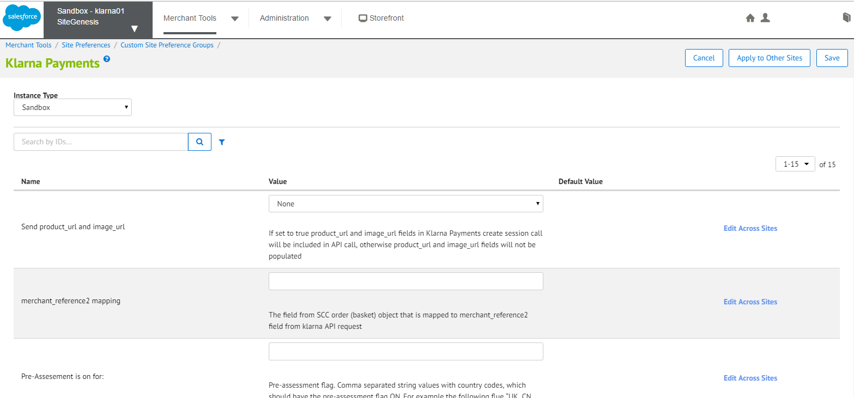

See full list below.

Besides configuration parameters, the following order attributes will be added:

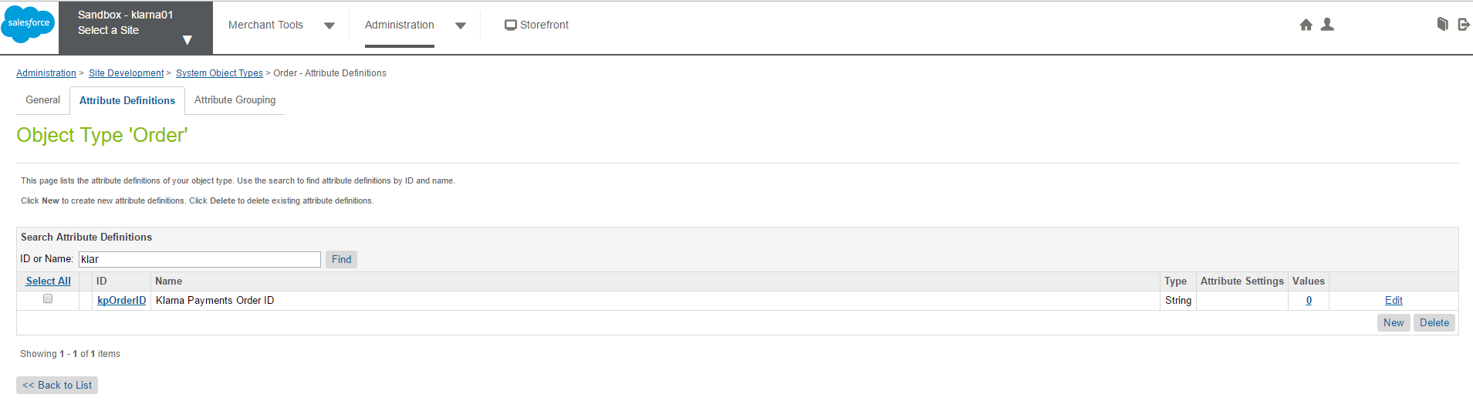

Custom Object Definition:

After importing metadata there will be a site specific custom object to store Klarna countries:

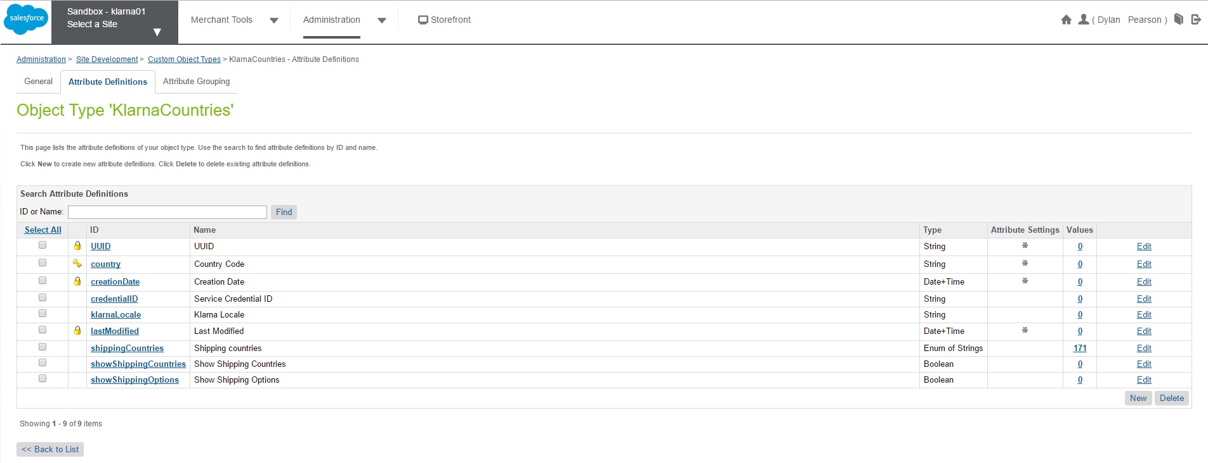

Note: The same custom object is used by Klarna Checkout

Defined as:

<custom-type type-id="KlarnaCountries">

<display-name xml:lang="x-default">Klarna Countries</display-name>

<staging-mode>source-to-target</staging-mode>

<storage-scope>site</storage-scope>

<key-definition attribute-id="country">

<display-name xml:lang="x-default">Country Code</display-name>

<type>string</type>

<min-length>0</min-length>

<field-length>0</field-length>

</key-definition>

<attribute-definitions>

<attribute-definition attribute-id="klarnaLocale">

<display-name xml:lang="x-default">Klarna Locale</display-name>

<type>string</type>

<localizable-flag>false</localizable-flag>

<mandatory-flag>false</mandatory-flag>

<externally-managed-flag>false</externally-managed-flag>

<min-length>0</min-length>

</attribute-definition>

<attribute-definition attribute-id="credentialID">

<display-name xml:lang="x-default">Service Credential ID</display-name>

<type>string</type>

<localizable-flag>false</localizable-flag>

<mandatory-flag>false</mandatory-flag>

<externally-managed-flag>false</externally-managed-flag>

<min-length>0</min-length>

</attribute-definition>

<attribute-definition attribute-id="showShippingOptions">

<display-name xml:lang="x-default">Show Shipping Options</display-name>

<type>boolean</type>

<mandatory-flag>false</mandatory-flag>

<externally-managed-flag>false</externally-managed-flag>

</attribute-definition>

<attribute-definition attribute-id="showShippingCountries">

<display-name xml:lang="x-default">Show Shipping Countries</display-name>

<type>boolean</type>

<mandatory-flag>false</mandatory-flag>

<externally-managed-flag>false</externally-managed-flag>

</attribute-definition>

<attribute-definition attribute-id="shippingCountries">

<display-name xml:lang="x-default">Shipping countries</display-name>

<type>enum-of-string</type>

<mandatory-flag>false</mandatory-flag>

<externally-managed-flag>false</externally-managed-flag>

<select-multiple-flag>true</select-multiple-flag>

<value-definitions>

<value-definition>

<display xml:lang="x-default">Afghanistan</display>

<value>AF</value>

</value-definition>

<value-definition>

<display xml:lang="x-default">Åland Islands</display>

<value>AX</value>

</value-definition>

<value-definition>

<display xml:lang="x-default">Albania</display>

<value>AL</value>

</value-definition>

<value-definition>

<display xml:lang="x-default">Algeria</display>

<value>DZ</value>

</value-definition>

<value-definition>

<display xml:lang="x-default">American Samoa</display>

<value>AS</value>

</value-definition>

<value-definition>

<display xml:lang="x-default">Andorra</display>

<value>AD</value>

</value-definition>

<value-definition>

<display xml:lang="x-default">Anguilla</display>

<value>AI</value>

</value-definition>

<value-definition>

<display xml:lang="x-default">Argentina</display>

<value>AR</value>

</value-definition>

<value-definition>

<display xml:lang="x-default">Armenia</display>

<value>AM</value>

</value-definition>

<value-definition>

<display xml:lang="x-default">Australia</display>

<value>AU</value>

</value-definition>

<value-definition>

<display xml:lang="x-default">Austria</display>

<value>AT</value>

</value-definition>

<value-definition>

<display xml:lang="x-default">Azerbaijan</display>

<value>AZ</value>

</value-definition>

<value-definition>

<display xml:lang="x-default">Bahrain</display>

<value>BH</value>

</value-definition>

<value-definition>

<display xml:lang="x-default">Bangladesh</display>

<value>BD</value>

</value-definition>

<value-definition>

<display xml:lang="x-default">Barbados</display>

<value>BB</value>

</value-definition>

<value-definition>

<display xml:lang="x-default">Belgium</display>

<value>BE</value>

</value-definition>

<value-definition>

<display xml:lang="x-default">Bermuda</display>

<value>BM</value>

</value-definition>

<value-definition>

<display xml:lang="x-default">Bhutan</display>

<value>BT</value>

</value-definition>

<value-definition>

<display xml:lang="x-default">Bolivia</display>

<value>BO</value>

</value-definition>

<value-definition>

<display xml:lang="x-default">Bosnia and Herzegovina</display>

<value>BA</value>

</value-definition>

<value-definition>

<display xml:lang="x-default">Brazil</display>

<value>BR</value>

</value-definition>

<value-definition>

<display xml:lang="x-default">British Indian Ocean Territory</display>

<value>IO</value>

</value-definition>

<value-definition>

<display xml:lang="x-default">British Virgin Islands</display>

<value>VG</value>

</value-definition>

<value-definition>

<display xml:lang="x-default">Brunei</display>

<value>BN</value>

</value-definition>

<value-definition>

<display xml:lang="x-default">Bulgaria</display>

<value>BG</value>

</value-definition>

<value-definition>

<display xml:lang="x-default">Cambodia</display>

<value>KH</value>

</value-definition>

<value-definition>

<display xml:lang="x-default">Canada</display>

<value>CA</value>

</value-definition>

<value-definition>

<display xml:lang="x-default">Cape Verde</display>

<value>CV</value>

</value-definition>

<value-definition>

<display xml:lang="x-default">Cayman Islands</display>

<value>KY</value>

</value-definition>

<value-definition>

<display xml:lang="x-default">Chad</display>

<value>TD</value>

</value-definition>

<value-definition>

<display xml:lang="x-default">Chile</display>

<value>CL</value>

</value-definition>

<value-definition>

<display xml:lang="x-default">China</display>

<value>CN</value>

</value-definition>

<value-definition>

<display xml:lang="x-default">Christmas Island</display>

<value>CX</value>

</value-definition>

<value-definition>

<display xml:lang="x-default">Cocos [Keeling] Islands</display>

<value>CC</value>

</value-definition>

<value-definition>

<display xml:lang="x-default">Colombia</display>

<value>CO</value>

</value-definition>

<value-definition>

<display xml:lang="x-default">Costa Rica</display>

<value>CR</value>

</value-definition>

<value-definition>

<display xml:lang="x-default">Croatia</display>

<value>HR</value>

</value-definition>

<value-definition>

<display xml:lang="x-default">Cyprus</display>

<value>CY</value>

</value-definition>

<value-definition>

<display xml:lang="x-default">Czech Republic</display>

<value>CZ</value>

</value-definition>

<value-definition>

<display xml:lang="x-default">Denmark</display>

<value>DK</value>

</value-definition>

<value-definition>

<display xml:lang="x-default">Dominican Republic</display>

<value>DO</value>

</value-definition>

<value-definition>

<display xml:lang="x-default">Ecuador</display>

<value>EC</value>

</value-definition>

<value-definition>

<display xml:lang="x-default">Egypt</display>

<value>EG</value>

</value-definition>

<value-definition>

<display xml:lang="x-default">El Salvador</display>

<value>SV</value>

</value-definition>

<value-definition>

<display xml:lang="x-default">Estonia</display>

<value>EE</value>

</value-definition>

<value-definition>

<display xml:lang="x-default">Ethiopia</display>

<value>ET</value>

</value-definition>

<value-definition>

<display xml:lang="x-default">Falkland Islands</display>

<value>FK</value>

</value-definition>

<value-definition>

<display xml:lang="x-default">Faroe Islands</display>

<value>FO</value>

</value-definition>

<value-definition>

<display xml:lang="x-default">Finland</display>

<value>FI</value>

</value-definition>

<value-definition>

<display xml:lang="x-default">France</display>

<value>FR</value>

</value-definition>

<value-definition>

<display xml:lang="x-default">French Guiana</display>

<value>GF</value>

</value-definition>

<value-definition>

<display xml:lang="x-default">French Polynesia</display>

<value>PF</value>

</value-definition>

<value-definition>

<display xml:lang="x-default">Gabon</display>

<value>GA</value>

</value-definition>

<value-definition>

<display xml:lang="x-default">Georgia</display>

<value>GE</value>

</value-definition>

<value-definition>

<display xml:lang="x-default">Germany</display>

<value>DE</value>

</value-definition>

<value-definition>

<display xml:lang="x-default">Gibraltar</display>

<value>GI</value>

</value-definition>

<value-definition>

<display xml:lang="x-default">Greece</display>

<value>GR</value>

</value-definition>

<value-definition>

<display xml:lang="x-default">Greenland</display>

<value>GL</value>

</value-definition>

<value-definition>

<display xml:lang="x-default">Guadeloupe</display>

<value>GP</value>

</value-definition>

<value-definition>

<display xml:lang="x-default">Guam</display>

<value>GU</value>

</value-definition>

<value-definition>

<display xml:lang="x-default">Guatemala</display>

<value>GT</value>

</value-definition>

<value-definition>

<display xml:lang="x-default">Guernsey</display>

<value>GG</value>

</value-definition>

<value-definition>

<display xml:lang="x-default">Guinea-Bissau</display>

<value>GW</value>

</value-definition>

<value-definition>

<display xml:lang="x-default">Haiti</display>

<value>HT</value>

</value-definition>

<value-definition>

<display xml:lang="x-default">Heard Island and McDonald Islands</display>

<value>HM</value>

</value-definition>

<value-definition>

<display xml:lang="x-default">Honduras</display>

<value>HN</value>

</value-definition>

<value-definition>

<display xml:lang="x-default">Hungary</display>

<value>HU</value>

</value-definition>

<value-definition>

<display xml:lang="x-default">Iceland</display>

<value>IS</value>

</value-definition>

<value-definition>

<display xml:lang="x-default">India</display>

<value>IN</value>

</value-definition>

<value-definition>

<display xml:lang="x-default">Indonesia</display>

<value>ID</value>

</value-definition>

<value-definition>

<display xml:lang="x-default">Isle of Man</display>

<value>IM</value>

</value-definition>

<value-definition>

<display xml:lang="x-default">Israel</display>

<value>IL</value>

</value-definition>

<value-definition>

<display xml:lang="x-default">Italy</display>

<value>IT</value>

</value-definition>

<value-definition>

<display xml:lang="x-default">Jamaica</display>

<value>JM</value>

</value-definition>

<value-definition>

<display xml:lang="x-default">Japan</display>

<value>JP</value>

</value-definition>

<value-definition>

<display xml:lang="x-default">Jersey</display>

<value>JE</value>

</value-definition>

<value-definition>

<display xml:lang="x-default">Jordan</display>

<value>JO</value>

</value-definition>

<value-definition>

<display xml:lang="x-default">Kazakhstan</display>

<value>KZ</value>

</value-definition>

<value-definition>

<display xml:lang="x-default">Kenya</display>

<value>KE</value>

</value-definition>

<value-definition>

<display xml:lang="x-default">Kuwait</display>

<value>KW</value>

</value-definition>

<value-definition>

<display xml:lang="x-default">Kyrgyzstan</display>

<value>KG</value>

</value-definition>

<value-definition>

<display xml:lang="x-default">Laos</display>

<value>LA</value>

</value-definition>

<value-definition>

<display xml:lang="x-default">Latvia</display>

<value>LV</value>

</value-definition>

<value-definition>

<display xml:lang="x-default">Lesotho</display>

<value>LS</value>

</value-definition>

<value-definition>

<display xml:lang="x-default">Liechtenstein</display>

<value>LI</value>

</value-definition>

<value-definition>

<display xml:lang="x-default">Lithuania</display>

<value>LT</value>

</value-definition>

<value-definition>

<display xml:lang="x-default">Luxembourg</display>

<value>LU</value>

</value-definition>

<value-definition>

<display xml:lang="x-default">Macedonia</display>

<value>MK</value>

</value-definition>

<value-definition>

<display xml:lang="x-default">Madagascar</display>

<value>MG</value>

</value-definition>

<value-definition>

<display xml:lang="x-default">Malaysia</display>

<value>MY</value>

</value-definition>

<value-definition>

<display xml:lang="x-default">Maldives</display>

<value>MV</value>

</value-definition>

<value-definition>

<display xml:lang="x-default">Malta</display>

<value>MT</value>

</value-definition>

<value-definition>

<display xml:lang="x-default">Marshall Islands</display>

<value>MH</value>

</value-definition>

<value-definition>

<display xml:lang="x-default">Martinique</display>

<value>MQ</value>

</value-definition>

<value-definition>

<display xml:lang="x-default">Mauritius</display>

<value>MU</value>

</value-definition>

<value-definition>

<display xml:lang="x-default">Mayotte</display>

<value>YT</value>

</value-definition>

<value-definition>

<display xml:lang="x-default">Mexico</display>

<value>MX</value>

</value-definition>

<value-definition>

<display xml:lang="x-default">Micronesia</display>

<value>FM</value>

</value-definition>

<value-definition>

<display xml:lang="x-default">Moldova</display>

<value>MD</value>

</value-definition>

<value-definition>

<display xml:lang="x-default">Monaco</display>

<value>MC</value>

</value-definition>

<value-definition>

<display xml:lang="x-default">Mongolia</display>

<value>MN</value>

</value-definition>

<value-definition>

<display xml:lang="x-default">Montenegro</display>

<value>ME</value>

</value-definition>

<value-definition>

<display xml:lang="x-default">Montserrat</display>

<value>MS</value>

</value-definition>

<value-definition>

<display xml:lang="x-default">Morocco</display>

<value>MA</value>

</value-definition>

<value-definition>

<display xml:lang="x-default">Mozambique</display>

<value>MZ</value>

</value-definition>

<value-definition>

<display xml:lang="x-default">Namibia</display>

<value>NA</value>

</value-definition>

<value-definition>

<display xml:lang="x-default">Nepal</display>

<value>NP</value>

</value-definition>

<value-definition>

<display xml:lang="x-default">Netherlands</display>

<value>NL</value>

</value-definition>

<value-definition>

<display xml:lang="x-default">New Caledonia</display>

<value>NC</value>

</value-definition>

<value-definition>

<display xml:lang="x-default">New Zealand</display>

<value>NZ</value>

</value-definition>

<value-definition>

<display xml:lang="x-default">Nicaragua</display>

<value>NI</value>

</value-definition>

<value-definition>

<display xml:lang="x-default">Niger</display>

<value>NE</value>

</value-definition>

<value-definition>

<display xml:lang="x-default">Nigeria</display>

<value>NG</value>

</value-definition>

<value-definition>

<display xml:lang="x-default">Norfolk Island</display>

<value>NF</value>

</value-definition>

<value-definition>

<display xml:lang="x-default">Northern Mariana Islands</display>

<value>MP</value>

</value-definition>

<value-definition>

<display xml:lang="x-default">Norway</display>

<value>NO</value>

</value-definition>

<value-definition>

<display xml:lang="x-default">Oman</display>

<value>OM</value>

</value-definition>

<value-definition>

<display xml:lang="x-default">Pakistan</display>

<value>PK</value>

</value-definition>

<value-definition>

<display xml:lang="x-default">Palau</display>

<value>PW</value>

</value-definition>

<value-definition>

<display xml:lang="x-default">Palestinian Territories</display>

<value>PS</value>

</value-definition>

<value-definition>

<display xml:lang="x-default">Panama</display>

<value>PA</value>

</value-definition>

<value-definition>

<display xml:lang="x-default">Papua New Guinea</display>

<value>PG</value>

</value-definition>

<value-definition>

<display xml:lang="x-default">Paraguay</display>

<value>PY</value>

</value-definition>

<value-definition>

<display xml:lang="x-default">Peru</display>

<value>PE</value>

</value-definition>

<value-definition>

<display xml:lang="x-default">Philippines</display>

<value>PH</value>

</value-definition>

<value-definition>

<display xml:lang="x-default">Pitcairn Islands</display>

<value>PN</value>

</value-definition>

<value-definition>

<display xml:lang="x-default">Poland</display>

<value>PL</value>

</value-definition>

<value-definition>

<display xml:lang="x-default">Portugal</display>

<value>PT</value>

</value-definition>

<value-definition>

<display xml:lang="x-default">Puerto Rico</display>

<value>PR</value>

</value-definition>

<value-definition>

<display xml:lang="x-default">Réunion</display>

<value>RE</value>

</value-definition>

<value-definition>

<display xml:lang="x-default">Romania</display>

<value>RO</value>

</value-definition>

<value-definition>

<display xml:lang="x-default">Russia</display>

<value>RU</value>

</value-definition>

<value-definition>

<display xml:lang="x-default">Saint Barthélemy</display>

<value>BL</value>

</value-definition>

<value-definition>

<display xml:lang="x-default">Saint Helena</display>

<value>SH</value>

</value-definition>

<value-definition>

<display xml:lang="x-default">Saint Martin</display>

<value>MF</value>

</value-definition>

<value-definition>

<display xml:lang="x-default">Saint Pierre and Miquelon</display>

<value>PM</value>

</value-definition>

<value-definition>

<display xml:lang="x-default">Saint Vincent and the Grenadines</display>

<value>VC</value>

</value-definition>

<value-definition>

<display xml:lang="x-default">San Marino</display>

<value>SM</value>

</value-definition>

<value-definition>

<display xml:lang="x-default">Saudi Arabia</display>

<value>SA</value>

</value-definition>

<value-definition>

<display xml:lang="x-default">Senegal</display>

<value>SN</value>

</value-definition>

<value-definition>

<display xml:lang="x-default">Serbia</display>

<value>RS</value>

</value-definition>

<value-definition>

<display xml:lang="x-default">Singapore</display>

<value>SG</value>

</value-definition>

<value-definition>

<display xml:lang="x-default">Slovakia</display>

<value>SK</value>

</value-definition>

<value-definition>

<display xml:lang="x-default">Slovenia</display>

<value>SI</value>

</value-definition>

<value-definition>

<display xml:lang="x-default">South Africa</display>

<value>ZA</value>

</value-definition>

<value-definition>

<display xml:lang="x-default">South Georgia and the South Sandwich Islands</display>

<value>GS</value>

</value-definition>

<value-definition>

<display xml:lang="x-default">South Korea</display>

<value>KR</value>

</value-definition>

<value-definition>

<display xml:lang="x-default">Spain</display>

<value>ES</value>

</value-definition>

<value-definition>

<display xml:lang="x-default">Sri Lanka</display>

<value>LK</value>

</value-definition>

<value-definition>

<display xml:lang="x-default">Svalbard and Jan Mayen</display>

<value>SJ</value>

</value-definition>

<value-definition>

<display xml:lang="x-default">Swaziland</display>

<value>SZ</value>

</value-definition>

<value-definition>

<display xml:lang="x-default">Sweden</display>

<value>SE</value>

</value-definition>

<value-definition>

<display xml:lang="x-default">Switzerland</display>

<value>CH</value>

</value-definition>

<value-definition>

<display xml:lang="x-default">Taiwan</display>

<value>TW</value>

</value-definition>

<value-definition>

<display xml:lang="x-default">Tajikistan</display>

<value>TJ</value>

</value-definition>

<value-definition>

<display xml:lang="x-default">Thailand</display>

<value>TH</value>

</value-definition>

<value-definition>

<display xml:lang="x-default">Trinidad and Tobago</display>

<value>TT</value>

</value-definition>

<value-definition>

<display xml:lang="x-default">Tunisia</display>

<value>TN</value>

</value-definition>

<value-definition>

<display xml:lang="x-default">Turkey</display>

<value>TR</value>

</value-definition>

<value-definition>

<display xml:lang="x-default">Turkmenistan</display>

<value>TM</value>

</value-definition>

<value-definition>

<display xml:lang="x-default">Turks and Caicos Islands</display>

<value>TC</value>

</value-definition>

<value-definition>

<display xml:lang="x-default">United Kingdom</display>

<value>GB</value>

</value-definition>

<value-definition>

<display xml:lang="x-default">United States</display>

<value>US</value>

</value-definition>

<value-definition>

<display xml:lang="x-default">Uruguay</display>

<value>UY</value>

</value-definition>

<value-definition>

<display xml:lang="x-default">U.S. Virgin Islands</display>

<value>VI</value>

</value-definition>

<value-definition>

<display xml:lang="x-default">Uzbekistan</display>

<value>UZ</value>

</value-definition>

<value-definition>

<display xml:lang="x-default">Vatican City</display>

<value>VA</value>

</value-definition>

<value-definition>

<display xml:lang="x-default">Venezuela</display>

<value>VE</value>

</value-definition>

<value-definition>

<display xml:lang="x-default">Vietnam</display>

<value>VN</value>

</value-definition>

<value-definition>

<display xml:lang="x-default">Wallis and Futuna</display>

<value>WF</value>

</value-definition>

<value-definition>

<display xml:lang="x-default">Zambia</display>

<value>ZM</value>

</value-definition>

</value-definitions>

</attribute-definition>

</attribute-definitions>

<group-definitions>

<attribute-group group-id="custom">

<display-name xml:lang="x-default">custom</display-name>

<attribute attribute-id="country"/>

<attribute attribute-id="klarnaLocale"/>

<attribute attribute-id="credentialID"/>

<attribute attribute-id="shippingCountries"/>

<attribute attribute-id="showShippingOptions"/>

<attribute attribute-id="showShippingCountries"/>

</attribute-group>

</group-definitions>

</custom-type>

### Cartridge Path

If using the controller based integration, cartridge path should be setup as such under Sites / Manage Sites /

app_storefront_controllers:app_storefront_core:int_klarna_payments_controllers:int_klarna_payments

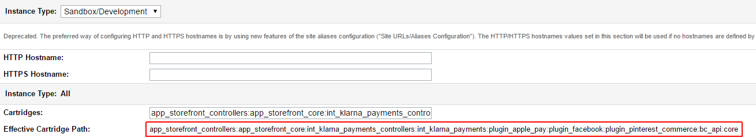

If using pipelines, the cartridge path should be similar to:

app_storefront_pipelines:app_storefront_core:int_klarna_payments_pipelines:int_klarna_payments

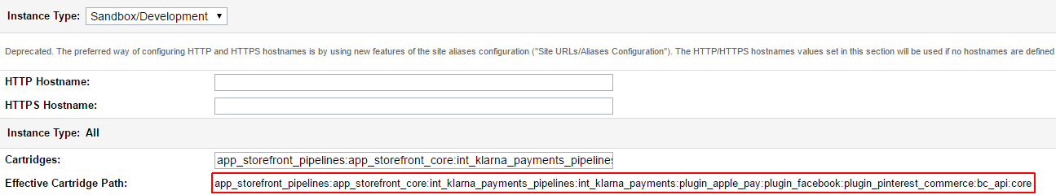

### Klarna Payments Configurations

Also, there is a page in Business Manager where you have to configure Klarna Payments cartridge, you can find it in Site Preferences > Custom Preferences > Klarna_Payments:



Here is the description of the Site Preferences fields which have to be configured:

|  |  |  |
| --- | --- | --- |
| **Parameter Name** | **Attribute ID** | **Description** |
| Send product_url and image_url | sendProductAndImageURLs | If set to true product_url and image_url fields in Klarna Payments create session call will be included in API call, otherwise product_url and image_url fields will not be populated. |
| Merchant Reference 2 Mapping | merchant_reference2_mapping | The field from SCC order (basket) object that is mapped to merchant_reference2 field from klarna API request.  Has to be one of the class attributes of SCC LineItemCtnr. Note that for complex data structures result may not always be as expected. |
| Pre-Assesement is on for: | kpPreAssessment | Pre-assessment flag. Comma separated string values with country codes, which should have the pre-assessment flag ON. For example the following flue “UK, CN, AU” would mean the pre-assessment is on for United Kingdom, China and Australia |
| Border Color Preference | kpColorBorder | CSS hex color to be used in Klarna Payments iFrame |
| Border Selected Color Preference | kpColorBorderSelected | CSS hex color to be used in Klarna Payments iFrame |
| Button Color Preference | kpColorButton | CSS hex color to be used in Klarna Payments iFrame |
| Button Text Color Preference | kpColorButtonText | CSS hex color to be used in Klarna Payments iFrame |
| Checkbox Color Preference | kpColorCheckbox | CSS hex color to be used in Klarna Payments iFrame |
| Checkbox Checkmark Color Preference | kpColorCheckboxCheckmark | CSS hex color to be used in Klarna Payments iFrame |
| Details Color Preference | kpColorDetails | CSS hex color to be used in Klarna Payments iFrame |
| Header Color Preference | kpColorHeader | CSS hex color to be used in Klarna Payments iFrame |
| Link Color Preference | kpColorLink | CSS hex color to be used in Klarna Payments iFrame |
| Text Color Preference | kpColorText | CSS hex color to be used in Klarna Payments iFrame |
| Secondary Text Color Preference | kpColorTextSecondary | CSS hex color to be used in Klarna Payments iFrame |
| Border Radius Preference | kpRadiusBorder | Size (in pixels) of the border radius to be used in Klarna Payments iFrame |
| Attachments | kpAttachments | Flag to swicth on/off the using of attachments when creating a session. Default is OFF. |
| Payment Method Title on Billing Page | kpPaymentMethodTitle | The Klarna Payment method title on billing page. JSON string holding country code and corresponding title string. For example:  {      **"GB"**:"Buy Now, Pay Later",    **"SE"**:"PIX",    **"default"**:"Klarna" } |

### Klarna Payments Logo and Payment Option Name

Payment option name in BM Merchant Tools > Ordering > Payment Methods should be Klarna.

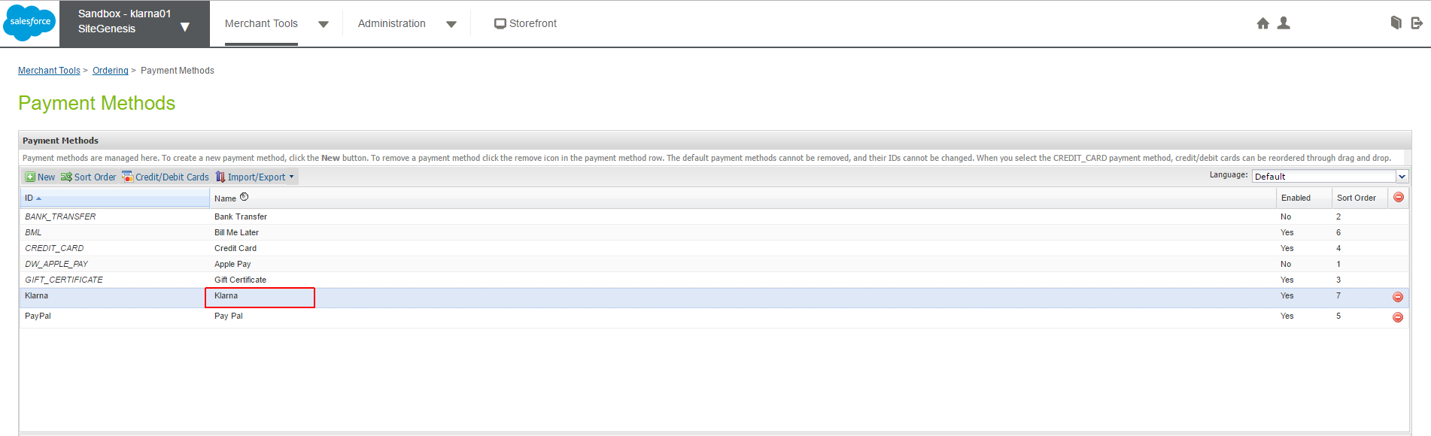

Payment option name can be changed trough BM Merchant Tools > Custom Site Preferences using the site preference kpPaymentMethodTitle (see above for details). If the kpPaymentMethodTitle preference value is not set the standard SG functionality to change the payment method name through BM Merchant Tools > Ordering > Payment Methods is applied

Logo can be changed from BM Merchant Tools > Ordering > Payment Methods. Enter the file name with the logo in the image field on payment method details view (see screenshot below)

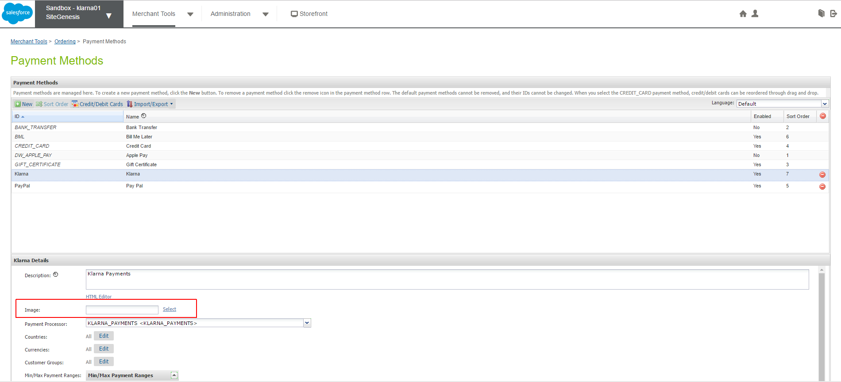

### Services Configuration

After the metadata import you should have klarna service ready in Administration > Operations > Services like so:

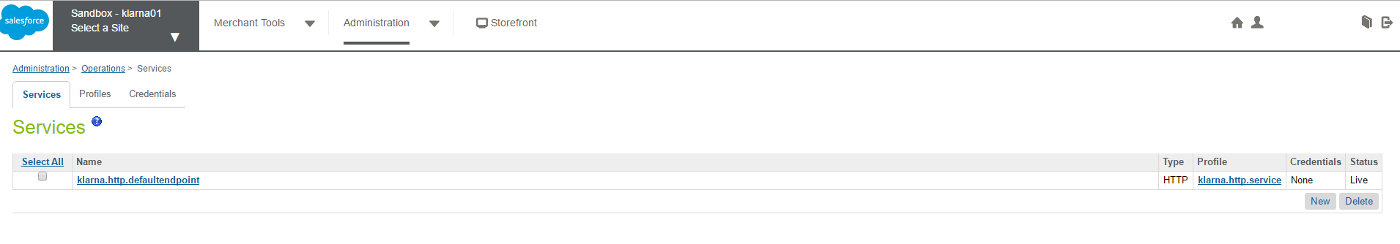

You need to configure Klarna Payments services credentials. Go to Credentials tab as shown below:

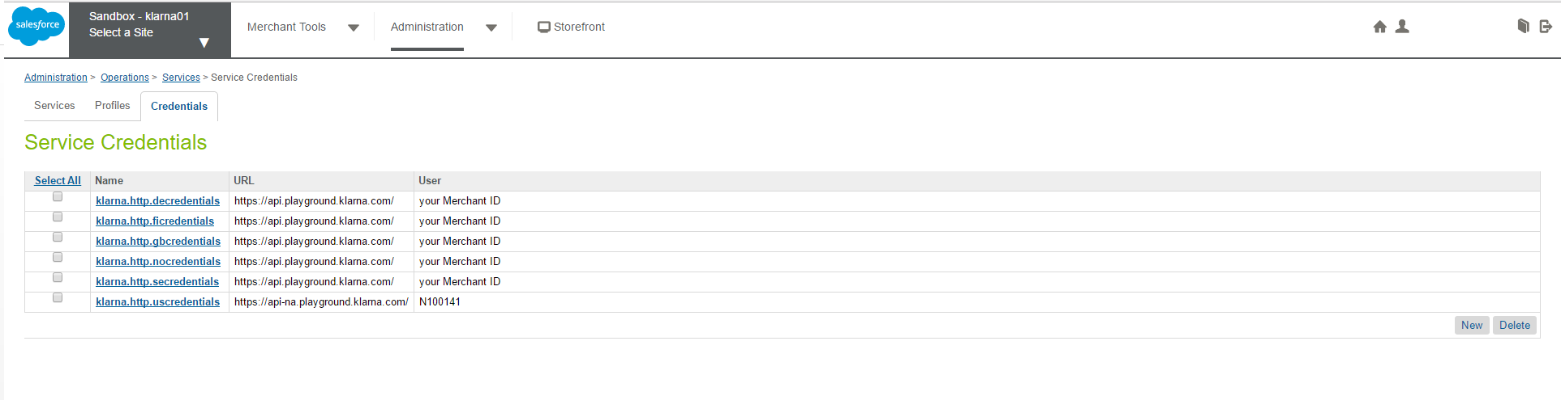

You need to edit the existing credentials or create new ones using the credentials provided to you by Klarna and the API URL for the specific location, see for example below:

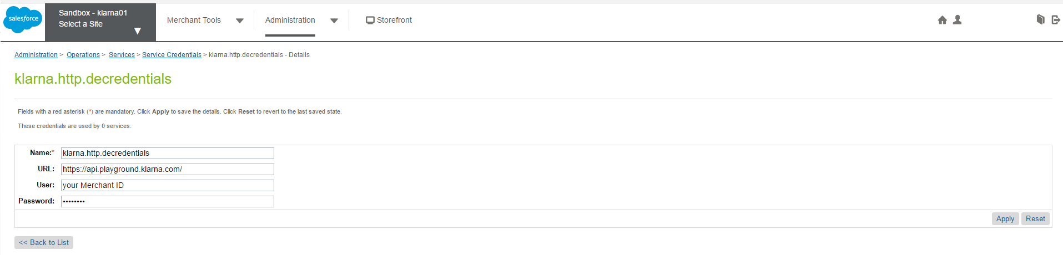

The Klarna Payments API is accessible through a few different URLS. There are different URLs for testing and for making live purchases as well as different URLs for depending on if you are based in Europe or in the U.S.

**Live environment**

The API for the European production environment can be found at

* https://api.klarna.com/

The API for the U.S. production environment can be found at

* https://api-na.klarna.com/

**Testing environment**

The API for the European testing environment can be found at

* https://api.playground.klarna.com/

The API for the U.S. testing environment can be found at

* https://api-na.playground.klarna.com/

### Custom attributes

ORDER system object has been extended with custom attribute kpOrderID of type string, which is holding the Klarna Payments Order ID, if Klarna Payments is used for the specific order

## Custom Code

Integration may vary based on the customers' storefront. Site Genesis version 2 is used to demonstrate Klarna Payments integration.

### Integration efforts

The following steps are needed to complete the integration:

* Install the cartridges
* Change and import ‘site-template.zip’ (system objects and custom objects)
* Do the required code changes
* Configure your merchant's Klarna Payments Account in the Klarna back office
* Configure Klarna Payments parameters in Commerce Cloud
* Test
* Create styling for Klarna Widget (optional)

These steps should not require more than a few hours.

Note that the name of your storefront site ID should match the name in the ‘site-template.zip’, otherwise you will get import errors.

Also, note that the payment methods ‘Klarna’ and the payment processors 'KLARNA_PAYMENTS' will be created or updated from the ‘site-template.zip’.

### Templates modifications

The following changes should be made regardless of whether a controller or a pipeline integration approach are being used.

To integrate Klarna Payments the following storefront cartridge templates should be updated:

* default/checkout/billing/billing.isml
* default/checkout/billing/paymentmethods.isml

**default/checkout/billing/billing.isml**

Add Code:

<script><isinclude template="/resources/klarnapaymentsresources.isml"/></script>

<script type="text/javascript" src="${URLUtils.staticURL('/js/klarna-payments.js')}"></script>

<script src="https://credit.klarnacdn.net/lib/v1/api.js" async></script>

Before</isdecorate> closing tag as shown below:

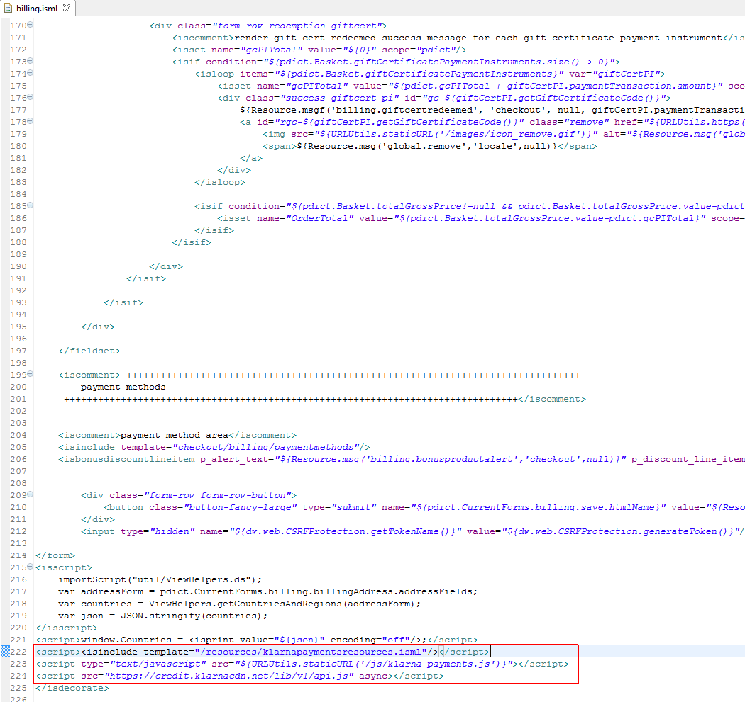

**default/checkout/billing/paymentmethods.isml**

Add code:

<isscript>

var Countries = require('int_klarna_payments/cartridge/scripts/util/Countries');

var countryCode = Countries.getCurrent({CurrentRequest: pdict.CurrentRequest}).countryCode;

var KlarnaPaymentMethodTitle = "Klarna";

if( !empty( dw.system.Site.getCurrent().getCustomPreferenceValue( 'kpPaymentMethodTitle' ) ) )

{

var kpPaymentMethodTitleJSON = JSON.parse( dw.system.Site.getCurrent().getCustomPreferenceValue( 'kpPaymentMethodTitle' ) );

if( kpPaymentMethodTitleJSON.hasOwnProperty(countryCode) )

{

KlarnaPaymentMethodTitle = kpPaymentMethodTitleJSON[countryCode.toString()];

}

}

</isscript>

Before <div class="payment-method-options form-indent"> close to line 12 as shown below:

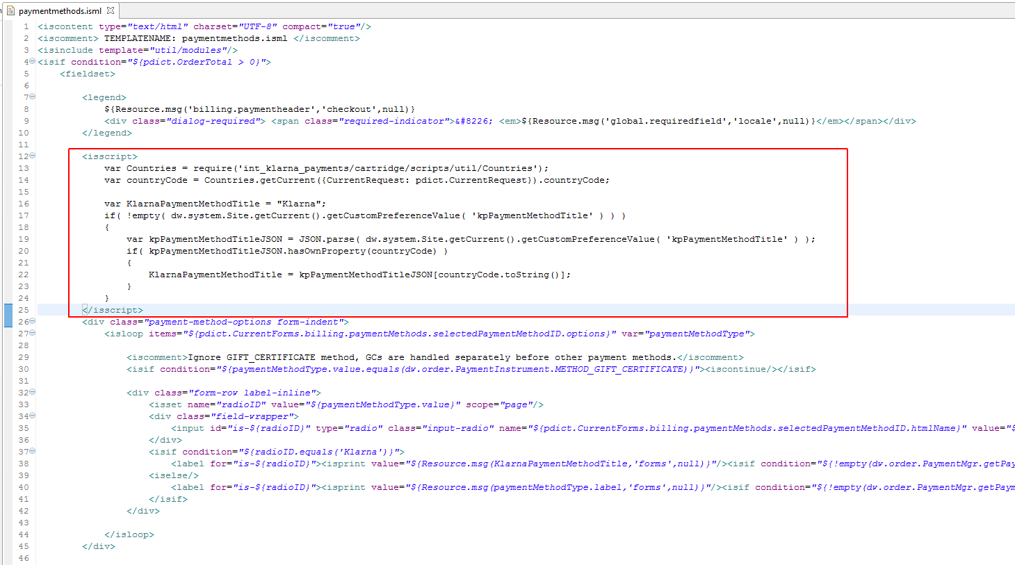

Replace:

<label for="is-${radioID}"><isprint value="${Resource.msg(paymentMethodType.label,'forms',null)}"/><isif condition="${!empty(dw.order.PaymentMgr.getPaymentMethod(paymentMethodType.value).image)}"><span> </span><img src="${dw.order.PaymentMgr.getPaymentMethod(paymentMethodType.value).image.getURL()}"></isif></label>

Just before the closing tag of <div class="form-row label-inline">

With the following:

<isif condition="${radioID.equals('Klarna')}">

<label for="is-${radioID}"><isprint value="${Resource.msg(KlarnaPaymentMethodTitle,'forms',null)}"/><isif condition="${!empty(dw.order.PaymentMgr.getPaymentMethod(paymentMethodType.value).image)}"><span> </span><img src="${dw.order.PaymentMgr.getPaymentMethod(paymentMethodType.value).image.getURL()}"></isif></label>

<iselse/>

<label for="is-${radioID}"><isprint value="${Resource.msg(paymentMethodType.label,'forms',null)}"/><isif condition="${!empty(dw.order.PaymentMgr.getPaymentMethod(paymentMethodType.value).image)}"><span> </span><img src="${dw.order.PaymentMgr.getPaymentMethod(paymentMethodType.value).image.getURL()}"></isif></label>

</isif>

As shown below:

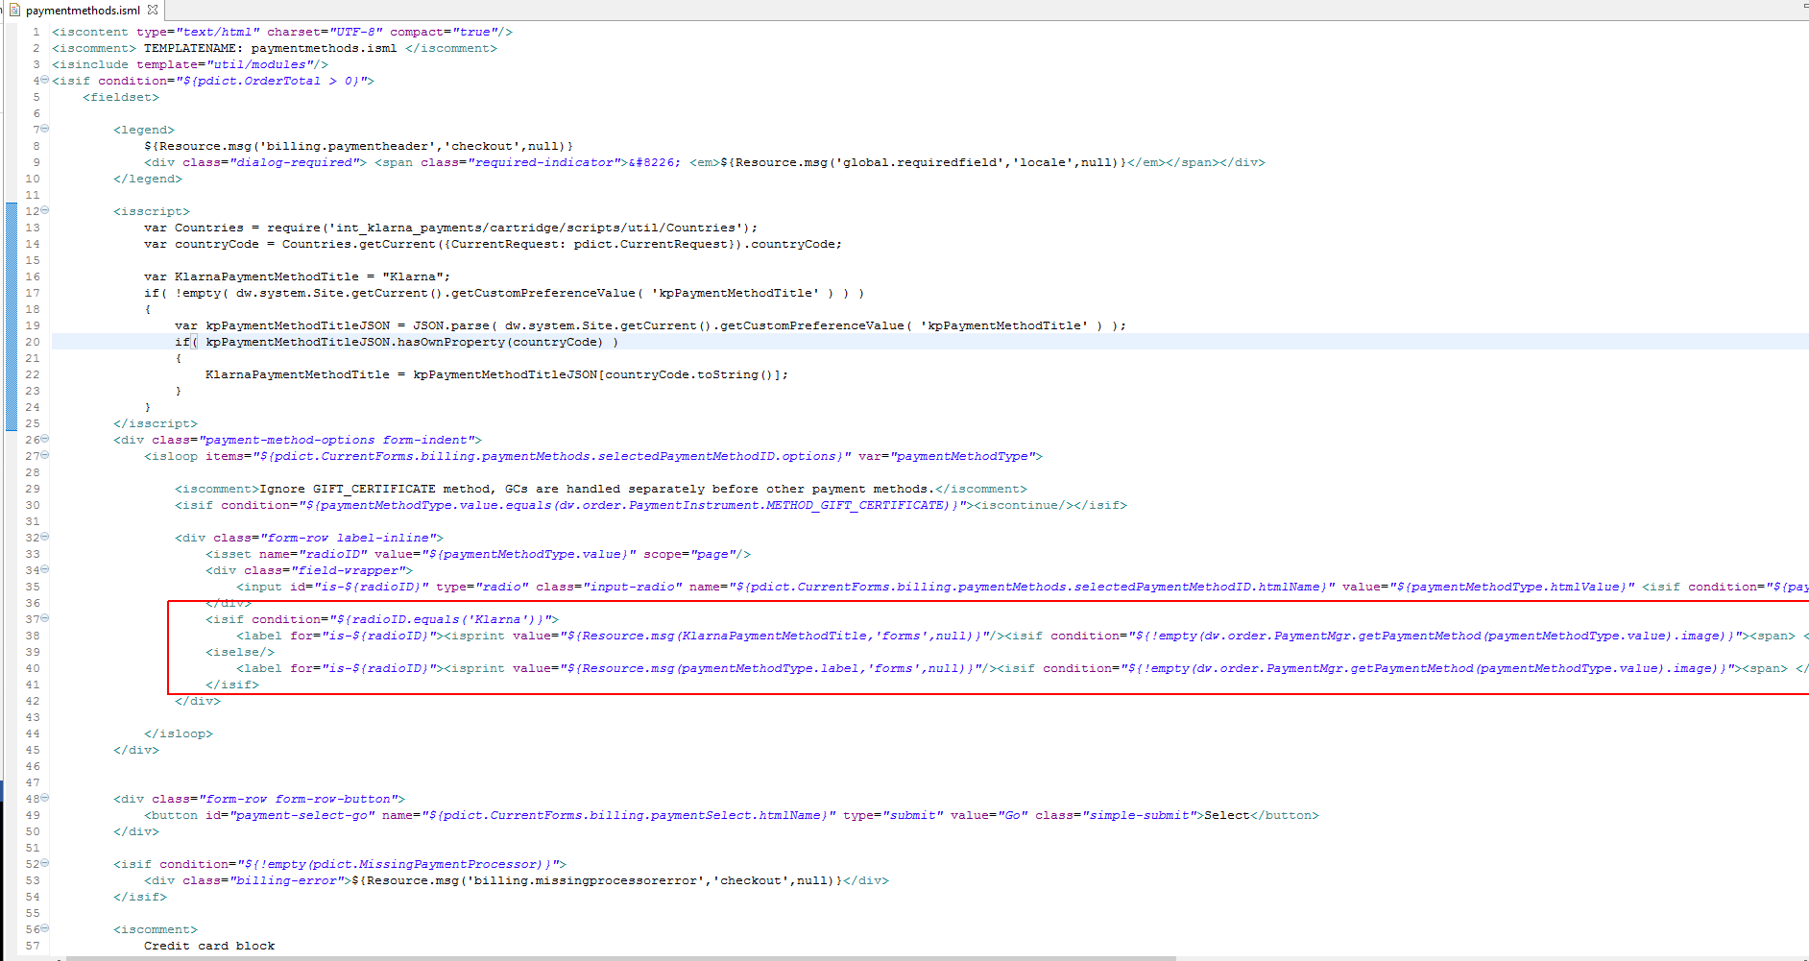

Add Code:

<isif condition="${!empty(dw.order.PaymentMgr.getPaymentMethod(paymentMethodType.value).image)}"><span> </span><img src="${dw.order.PaymentMgr.getPaymentMethod(paymentMethodType.value).image.getURL()}"></isif>

After <isprint value="${Resource.msg(paymentMethodType.label,'forms',null)}"/>

Close to line 23 as shown below:

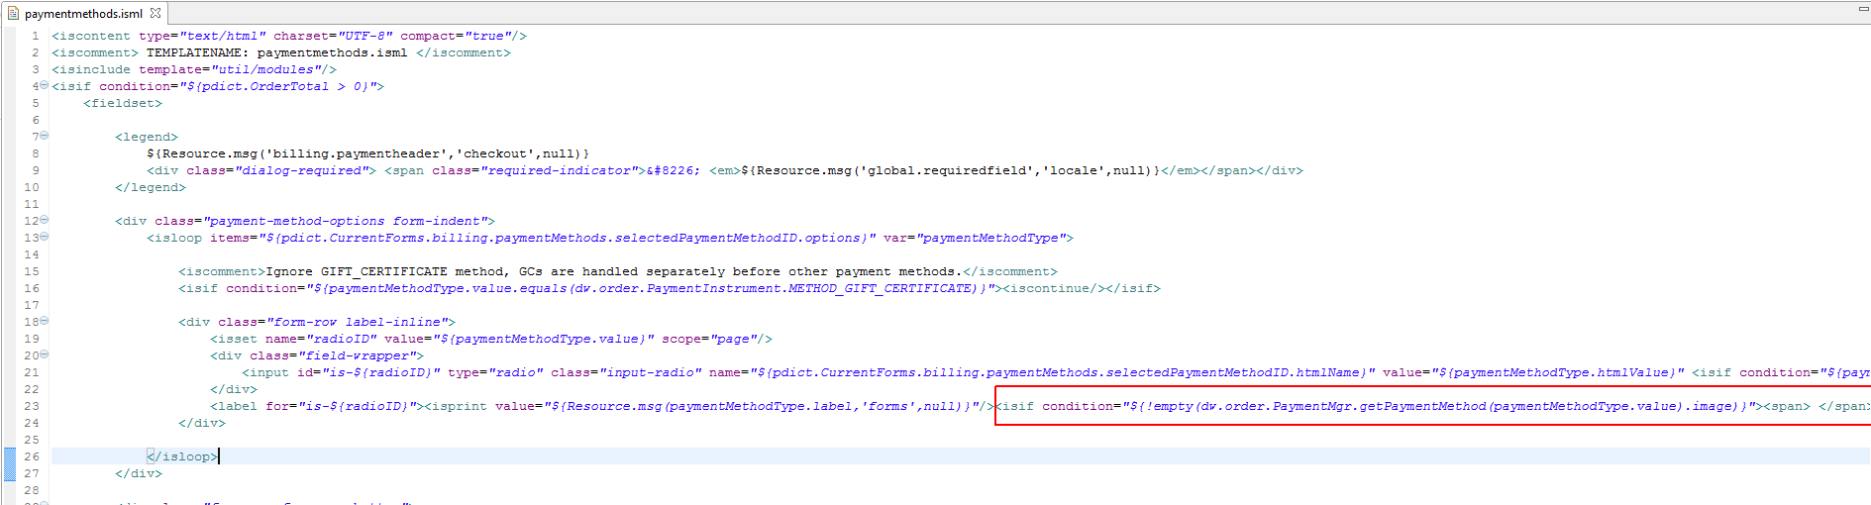

Add Code:

<iscomment>Klarna Payments --------------------------------------------------------------</iscomment>

<div class="payment-method <isif condition="${!empty(pdict.selectedPaymentID) && pdict.selectedPaymentID=='PayPal'}">payment-method-expanded</isif>" data-method="Klarna">

<div id="klarna_payments_container" style="text-align: center;"></div>

<isif condition="${empty(session.custom.KlarnaPaymentsSessionID)}">

<div id="klarna_payments_error" style="text-align: center; font-weight: bold; color: red;">${Resource.msg('klarna.payments.error.unavailable', 'klarnapayments', null)}</div>

</isif>

</div>

Before</fieldset> closing tag as shown below:

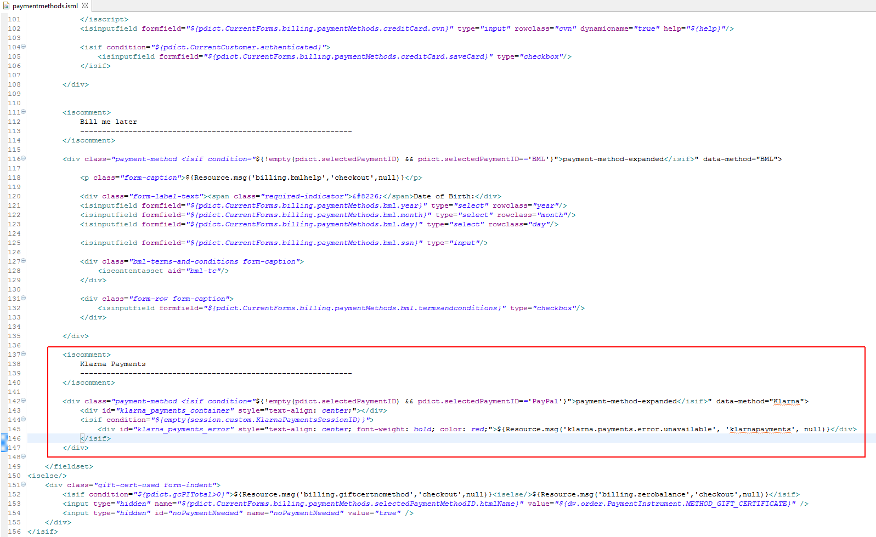

### Pipeline modifications

If using a pipeline based SiteGenesis integration, additionally follow the instructions in this chapter. If integrating via the controller based model see next chapter.

To use Klarna Payments cartridge you will need to make the following changes in pipelines.

### COBilling pipeline

Go to COBilling pipeline, Start node and add KLARNA_PAYMENTS-CreateSession call node entry point before checkout/billing/billing -> Billing interaction continue node (see screen shot below)

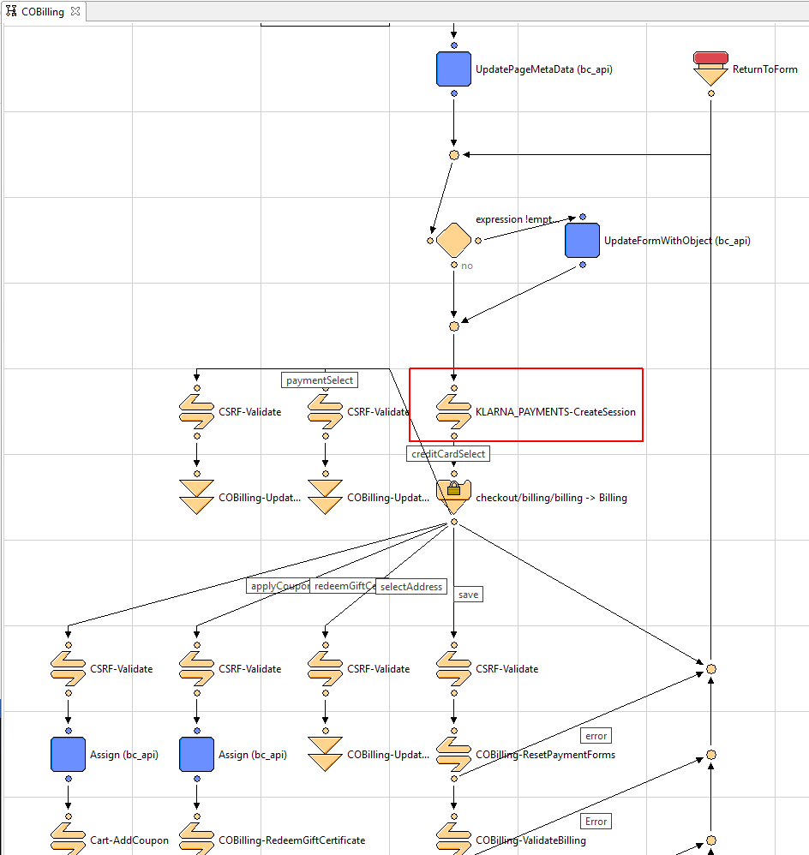

### COSummary pipeline.

Go to COSummary pipeline, Submit node and add KLARNA_PAYMENTS-Redirect call node entry point before COSummary-ShowConfirmation jump node (see screen shot below)

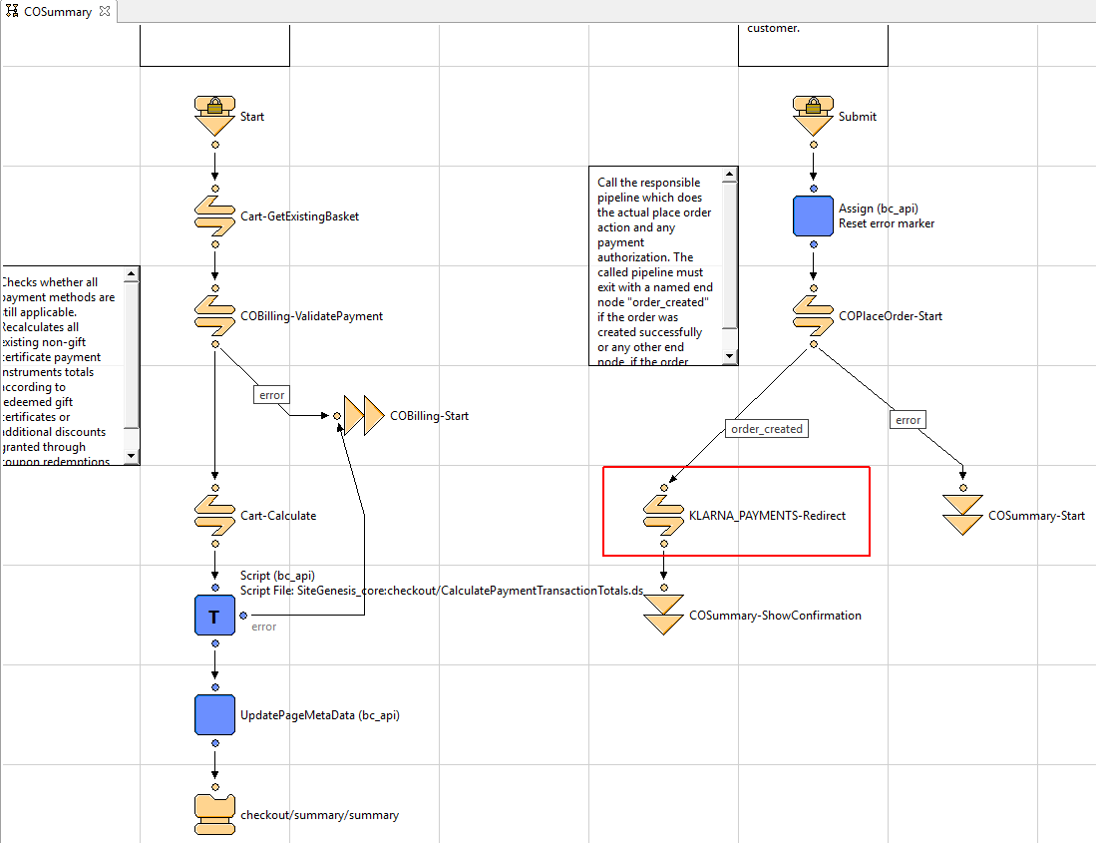

### COPlaceOrder pipeline.

Go to COPlaceOrder pipeline, PlaceOrder node and add KLARNA_PAYMENTS-PendingOrder call node entry point before PlaceOrder script node node (see screen shot below). Create ‘pending’ and ‘error’ transitions and end nodes as shown on the screenshot

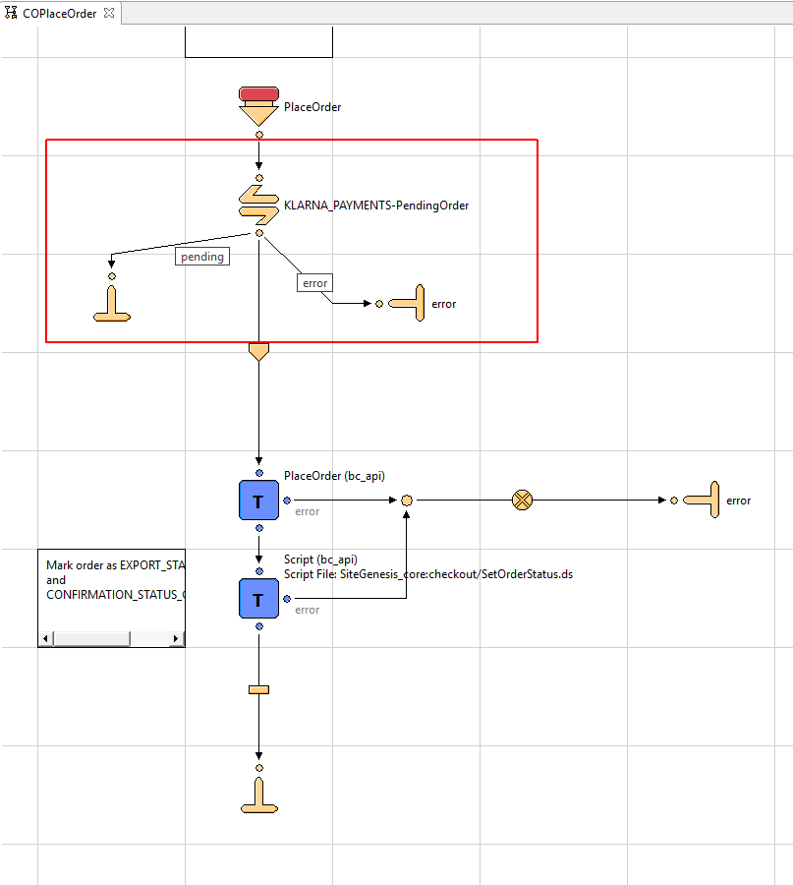

### Controller modifications

If using a controller based SiteGenesis integration, additionally follow the instructions in this chapter. If integrating via the pipeline method please see Pipeline modifications chapter above.

### COBilling controller.

Go to COBilling controller, returnToForm method and add the following code block:

**try**

{

require('int_klarna_payments_controllers/cartridge/controllers/KLARNA_PAYMENTS.js').CreateSession();

} **catch**( e )

{

require( 'dw/system/Logger' ).getLogger( 'COBilling.js' ).error( 'Klarna Create Session Error: {0}', e );

}

*after pageMeta.update (see screen shot below)*

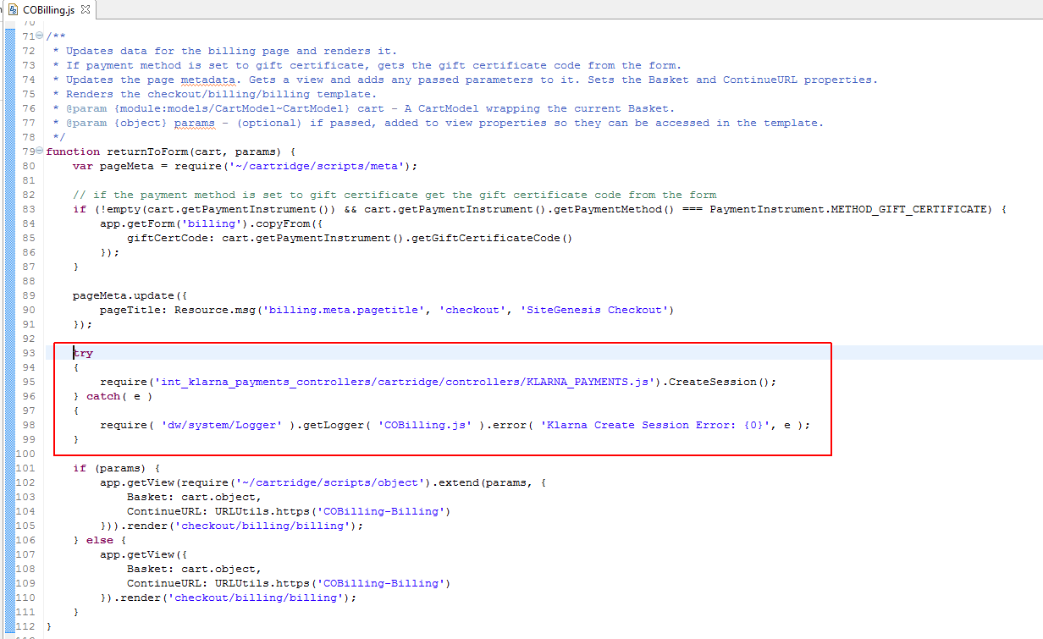

### COSummary controller.

Go to COSummary controller, submit() method and add the following code block:

**try**

{

require('int_klarna_payments_controllers/cartridge/controllers/KLARNA_PAYMENTS.js').Redirect();

} **catch**( e )

{

require( 'dw/system/Logger' ).getLogger( 'COSummary.js' ).error( 'Klarna Redirect Error: {0}', e );

}

***before*** showConfirmation(placeOrderResult.Order)(see screen shot below)

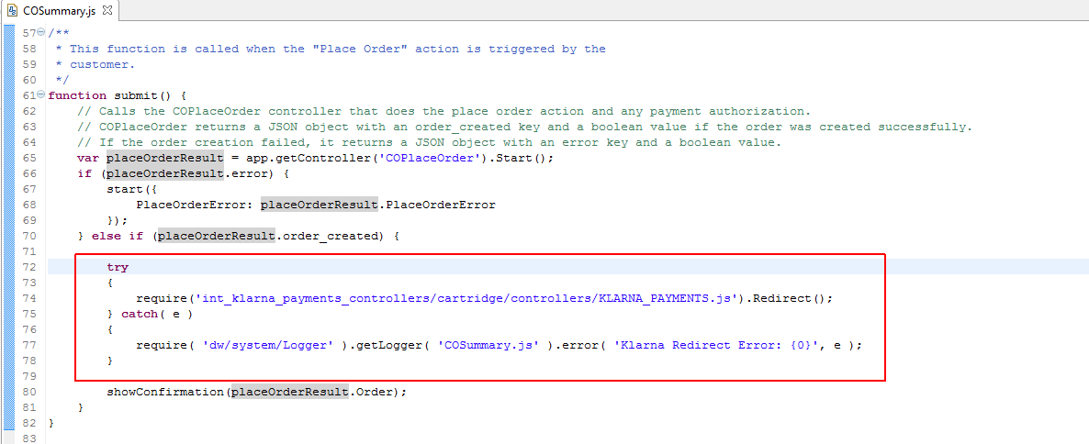

### OrderModel.js

Go to OrderModel.js, placeOrder method and add the following code block:

**if**( session.custom.KlarnaPaymentsFraudStatus === 'PENDING' )

{

**try**

{

require('int_klarna_payments_controllers/cartridge/controllers/KLARNA_PAYMENTS.js').PendingOrder();

} **catch**( e )

{

require( 'dw/system/Logger' ).getLogger( 'OrderModel.js' ).error( 'Klarna Payments Pending Order Error: {0}', e );

}

**return**;

}

**before**var placeOrderStatus = OrderMgr.placeOrder(order); (see screen shot below)

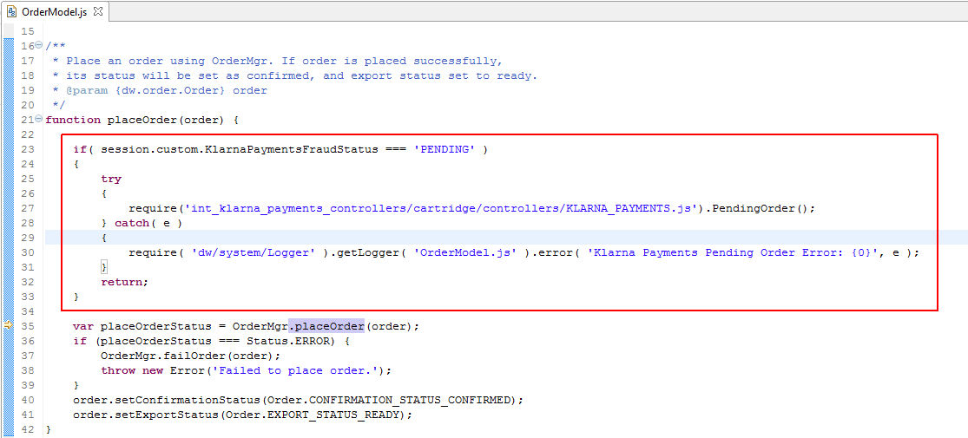

## External Interfaces

<INTERFACES TO EXTERNAL SERVICES, E.G HTTP CLIENT, WEBSERVICE CALLS, DESCRIPTION OF REQUESTS AND RESPONSES>

## Testing

*<SAMPLE DATA, TEST ACCOUNT, TEST CASES, REFERENCE TO CERTIFICATION REQUIREMENTS>*

# Operations, Maintenance

## Data Storage

*<DESCRIBE ANY DATA THAT WILL BE STORED WITHIN DEMANDWARE, E.G. CUSTOM OBJECTS, INCLUDING DURATION AND CLEANUP JOBS IF APPLICABLE>*

<IS THERE A SEPARATE DATA STORAGE OUTSIDE OF DEMANDWARE, SPECIFY LOCATION AND DURATION IF APPLICABLE>

## Availability

<EXPECTED AVAILABILITY /UPTIME OF ANY EXTERNAL SERVICE, INTERFACES>

<FALLBACK SOLUTION, BEHAVIOR IF EXTERNAL SERVICES ARE NOT AVAILABLE, IMPACT ON CUSTOMER STOREFRONT>

<ANY EXISTING UTILITIES THAT HELP TO DETECT AVAILABILITY/UPTIME OF EXTERNAL SERVICE, E.G. WEBSERVICE CALL, GOMEZ PING>

<ESTIMATED PERFORMANCE METRICS FOR PEAK BUSINESS HOURS IF AVAILABLE>

<NOTIFICATION PROCESS IF EXTERNAL SERVICES, INTERFACES ARE NOT RESPONDING, E.G. HOTLINE /SUPPORT PHONE NUMBER>

## Support

<CONTACT PERSON IN CASE DEFECT FIXES OR IMPROVEMENTS FOR COMPONENT ARE REQUIRED>

# User Guide

## Roles, Responsibilities

*<LIST RECURRING TASKS THAT NEED TO BE FULFILLED BY CUSTOMER, MERCHANT TO RUN THE INTEGRATION, E.G. MANUAL FEED OF CATALOG DATA INTO 3RD PARTY SERVICE, IF APPLICABLE>*

## Business Manager

<UI SCREENSHOTS AND DESCRIBTION OF FUNCTIONALITY>

<DESCRIBE NEW BUSINESS MANAGER MODULES AND CONFIGURATION OPTIONS IF APPLICABLE>

## Storefront Functionality

*<DESCRIBE NEW STOREFRONT FUNCTIONALITY>*

# Known Issues

*<LIST KNOWN ISSUES AND WORKAROUNDS>*

# Release History

<RELEASE HISTORY OF THE COMPONENT; THIS DOCUMENT IS PART OF THE COMPONENT AND DOES NOT HAVE ITS OWN RELEASE/VERSION NUMBER.>

*<PLEASE USE THE FOLLOWING NAMING SCHEMA: CHANGES TO THE 1ST DIGIT CONTAIN INCOMPATIBILITIES, CHANGES TO THE 2ND DIGIT PROVIDE NEW MINOR FEATURES WITHOUT CAUSING INCOMPATIBILITY, A CHANGE TO THE 3RD DIGIT PROVIDES BUG FIXES WITHOUT INTRODUCING NEW FEATURES>*

|  |  |  |
| --- | --- | --- |
| **Version** | **Date** | **Changes** |
| 1.0.0 | <DATE> | Initial release |